**FOOD CONNECT**

To supply leftover food to poor

NAME:GURU RAGHAVENDRA KAMBOJI

COLLEGE:Annamacharya Institute Of Technology and Sciences,Rajampet

EMAIL:kraghava234@gmail.com

**Project Overview:**

**CRM System for Leftover Food Distribution to the Needy:**

This project is designed to create a platform that efficiently connects food donors (such as restaurants, food businesses, and households) with charitable organizations and individuals in need. The goal is to reduce food waste by redistributing leftover food to the poor and marginalized communities. The CRM system will manage the entire process—from receiving food donations to organizing and tracking distributions—ensuring that food reaches those who need it most.

**Key features include:**

* **Donation Management**: A comprehensive tracking system for logging food donations, including donor details, type of food, quantity, and expiration dates.
* **Recipient Coordination**: A database to manage and categorize recipient organizations (e.g., shelters, food banks) and direct beneficiaries (e.g., low-income families), ensuring equitable distribution.
* **Delivery Logistics**: Integrated scheduling and routing for food pickup and delivery, helping to reduce waste and ensure food is delivered in a timely manner.
* **Volunteer and Resource Management**: Tools to coordinate volunteers who will help with food collection, packaging, and distribution, maximizing operational efficiency.
* **Impact Tracking and Reporting**: Analytics tools that monitor and report on the volume of food redistributed, tracking how many people are served, and measuring the project's social impact.

This CRM system meets critical business needs by addressing food insecurity, reducing food waste, and enhancing the efficiency of charitable food distribution efforts. It helps organizations work more effectively, ensuring that no food goes to waste while supporting those in dire need.

**Objectives:**

The primary objective of building the FOODCONNECT CRM is to create a structured, technology-driven platform that manages the collection and distribution of leftover food from restaurants, hotels, and events to underprivileged communities. By leveraging Salesforce CRM capabilities, the system ensures efficient tracking of food donations, automates the scheduling and logistics of pickups and deliveries, and maintains comprehensive records of donors and beneficiaries. This initiative not only reduces food wastage but also fosters stronger relationships with donors through systematic communication and appreciation. Additionally, the CRM enhances operational transparency and accountability by generating insightful reports, which aids in scaling the initiative, attracting new partners, and building trust with stakeholders. Ultimately, the project delivers significant social value by bridging the gap between surplus food sources and those in need, while streamlining processes that traditionally suffer from manual inefficiencies.

**Phase 1: Requirement Analysis & Planning**

**Understanding Business Requirements:** The key requirement of this project is to establish an organized platform that connects restaurants, hotels, and event organizers willing to donate leftover food with NGOs or volunteer groups who can distribute it to the poor. The system needs to efficiently track food availability, coordinate pickups and deliveries, monitor beneficiary reach, and maintain transparent records. Users require a solution that minimizes manual coordination, prevents food spoilage, and ensures that surplus food is safely and quickly routed to the needy.

**Defining Project Scope and Objectives:**

* Develop a CRM system on Salesforce to register and manage profiles of donors (restaurants, hotels) and recipients (NGOs, shelters, volunteer groups).
* Automate the process of scheduling pickups and assigning delivery tasks based on food type, quantity, and location.
* Maintain historical records of donations and distributions to enable tracking and reporting.
* Implement notifications and reminders for timely pickups, and acknowledgements to donors after successful delivery.
* Generate insightful dashboards to visualize the amount of food saved, number of beneficiaries served, and partner engagement, aiding in promoting the initiative and attracting new donors.

**Design Data Model and Security Model:**

The data model includes custom objects like Donor, Food Donation, Pickup Schedule, Recipient, and Distribution Record, linked through appropriate relationships to maintain a clear trail from donation to delivery. The security model employs profiles and role hierarchies to ensure that restaurant managers, NGO coordinators, and volunteer drivers have access only to the data relevant to their roles. Permission sets and sharing rules are configured to maintain data privacy while supporting collaborative workflows among multiple partners.

**Phase 2: Salesforce Development - Backend & Configurations**

**Setup environment & DevOps workflow:** A dedicated Salesforce sandbox environment was set up for the development and initial testing of the FOODCONNECT CRM. This enabled isolated customization without impacting production data. A simple DevOps process was followed using Change Sets to migrate metadata from the sandbox to production, ensuring controlled deployments and version management.

**Customization of Objects, Fields, Validation Rules, Automation:**

Create Venue Object

To create an object:

1. From the setup page >> Click on Object Manager >> Click on Create >>Click on Custom Object.

* Enter the label name >> Venue
* Plural label name >> Venues
* Enter Record Name Label and Format

1.Record Name >> Venue Name

2.Data Type >> Text

2.Click on Allow reports and Track Field History, Allow Activities.

3.Allow search >> Save.

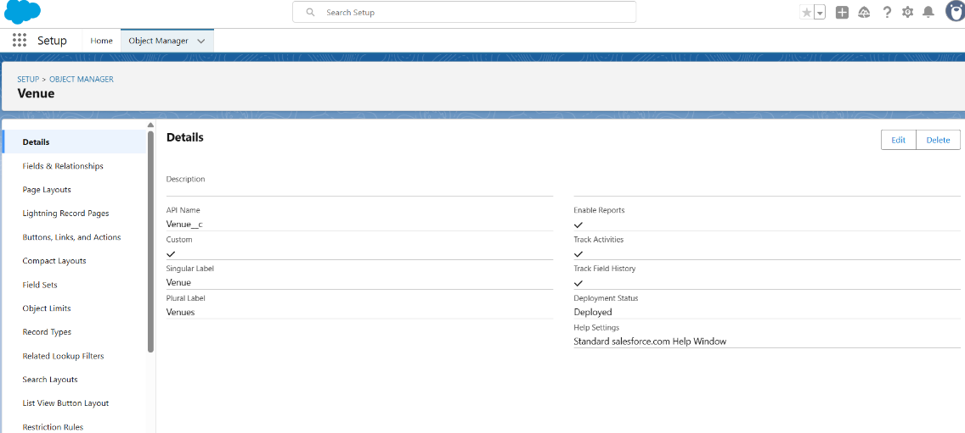

**Create Drop-Off Point Object**

To create an object:

1. From the setup page >> Click on Object Manager >> Click on Create >> Click on Custom Object.

* Enter the label name >> Drop-Off Point
* Plural label name>> Drop-Off Points
* Enter Record Name Label and Format

a. Record Name >> Drop-Off point Name

b. Data Type >> Text

2. Click on Allow reports and Track Field History, Allow Activities

3. Allow search >> Save.

**Create Task Object**

To create an object:

1. From the setup page >> Click on Object Manager >> Click on Create >> Click on Custom Object.
2. Enter the label name>> Task
3. Plural label name>> Tasks
4. Enter Record Name Label and Format

* Record Name >> Task Name
* Data Type >> Text

1. Click on Allow reports and Track Field History,Allow Activities
2. Allow search >> Save

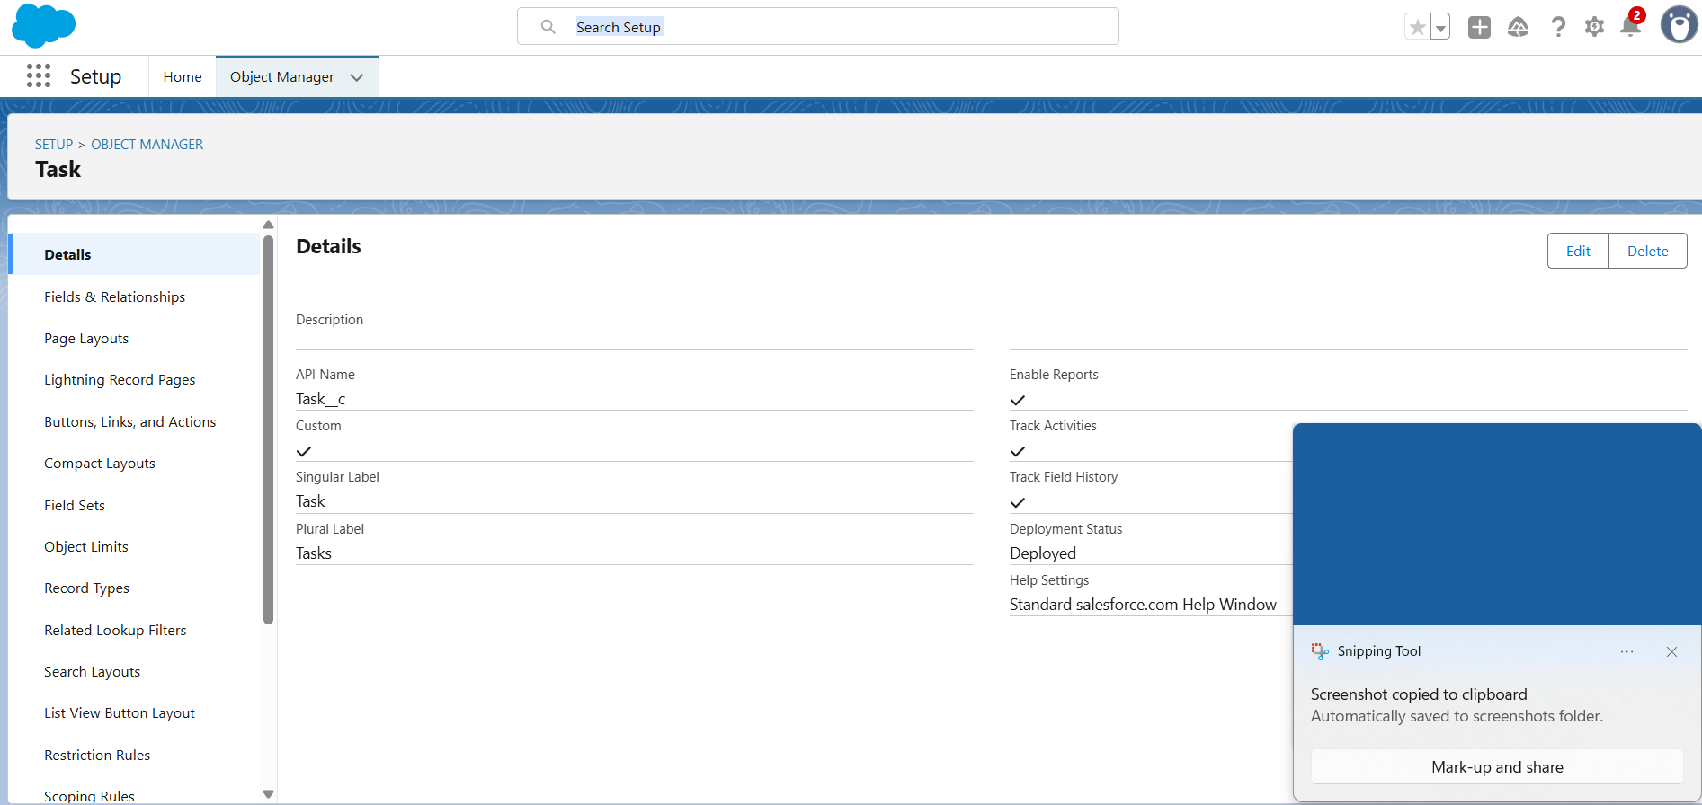

**Create Volunteer Object**

To create an object:

1. From the setup page >> Click on Object Manager>> Click on Create >> Click on Custom Object.
2. Enter the label name>> Volunteer
3. Plural label name>> Volunteers
4. Enter Record Name Label and Format

* Record Name >> Volunteer Name
* Data Type >> Text

1. Click on Allow reports and Track Field History, Allow Activities
2. Allow search >> Save.

**Create Execution Details Object**

To create an object:

1. From the setup page >> Click on Object Manager >> Click on Create >> Click on Custom Object.
2. Enter the label name >> Execution Detail
3. Plural label name >> Execution Details
4. Enter Record Name Label and Format

* Record Name >> Execution Detail Name
* Data Type >> Text

1. Click on Allow reports and Track Field History, Allow Activities
2. Allow search >> Save.

**Creation of Relationship fields in objects**

Creation of Lookup Relationship Field on Volunteer Object:

1. Go to setup >> click on Object Manager >> type object name (Volunteer) in the search bar >> click on the object.
2. Now click on “Fields & Relationships” >> New
3. Select Master Detail relationship
4. Select the related object “Drop-Off point” and click next.

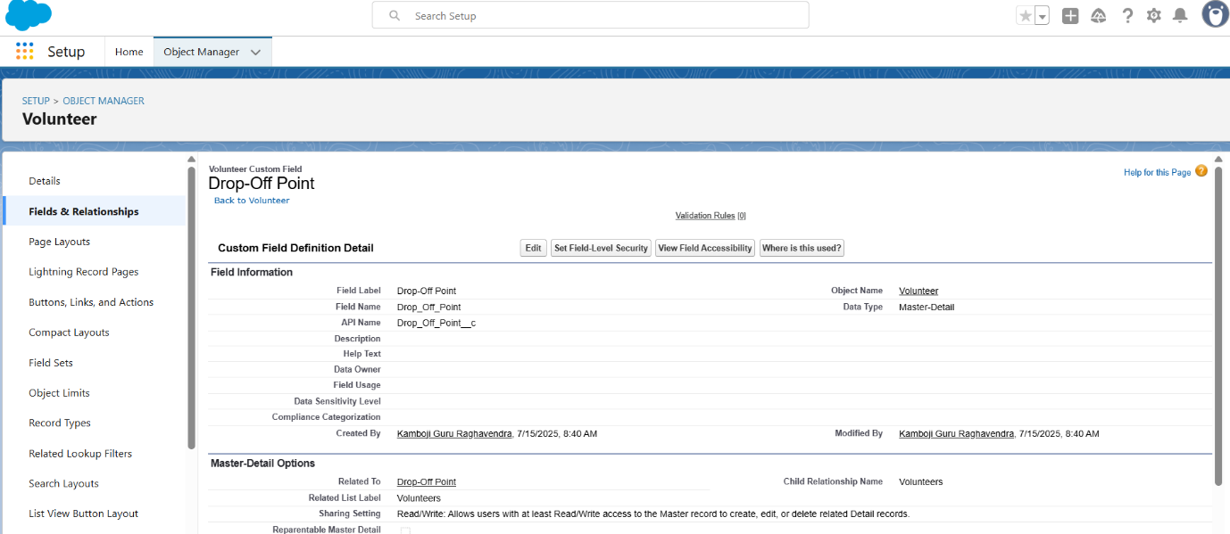

1. Field Name: Drop_off point
2. Field label: Auto generated
3. Next >> Next >> Save.

Creation of Master Detail Relationship Field on Execution Details Object:

1. Go to setup >> click on Object Manager >> type object name (Execution Details) in the search bar >> click on the object.
2. Now click on “Fields & Relationships” >> New
3. Select Master Detail relationship
4. Select the related object “Volunteer” and click next.

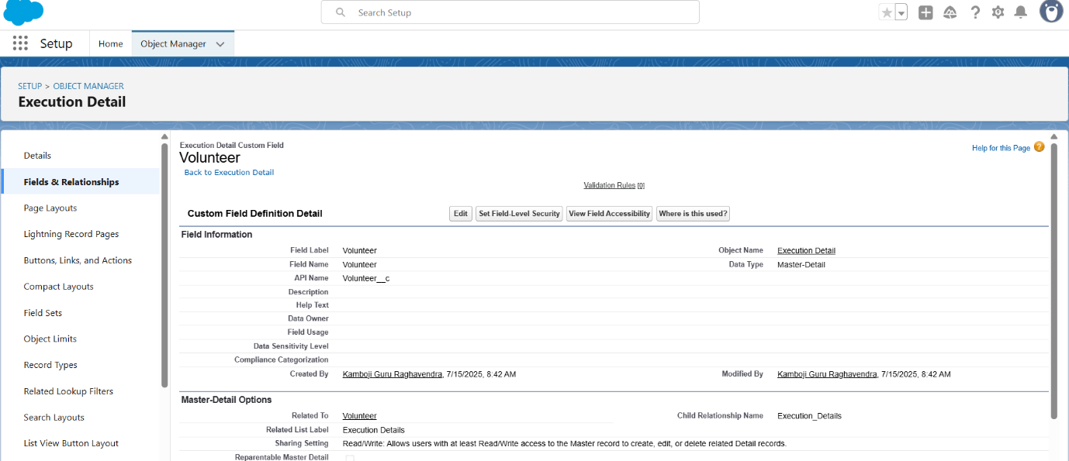

1. Field Name: Volunteer
2. Field label: Auto generated
3. Next >> Next >> Save.

Creation of Master Detail Relationship Field on Execution Details Object :

1. Go to setup >> click on Object Manager >> type object name(Execution Details) in the search bar >> click on the object.
2. Now click on “Fields & Relationships” >> New
3. Select Master Detail relationship
4. Select the related object “Task” and click next.
5. Field Name: Task

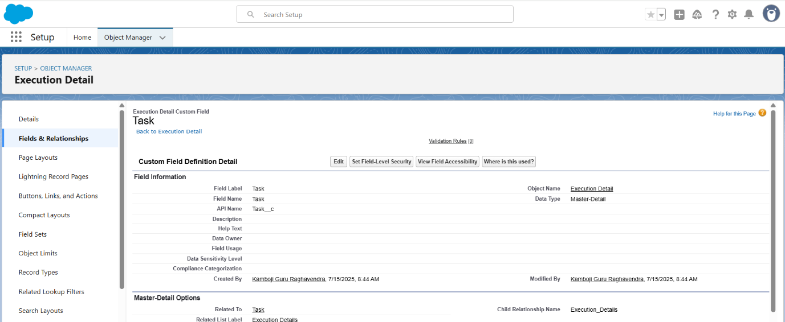

1. Field label: Auto generated
2. Next >> Next >> Save.

Creation of Lookup Relationship Field on Drop-Off Point Object:

1. Go to setup >> click on Object Manager >> type object name (Drop-Off Point) in the search bar >> click on the object.
2. Now click on “Fields & Relationships” >> New
3. Select Lookup relationship
4. Select the related object “Venue” and click next.

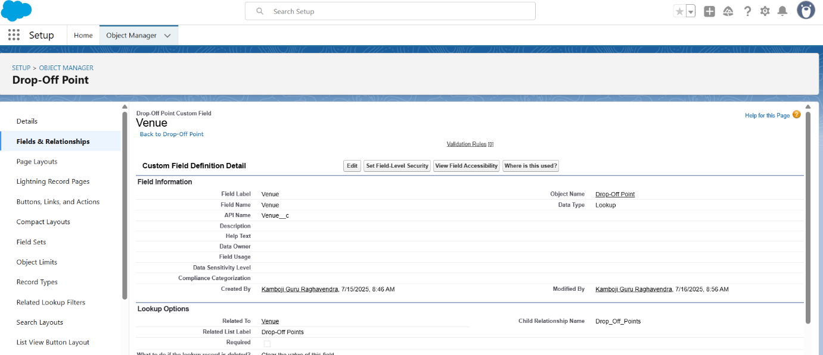

1. Field Name: Venue
2. Field label: Venue__c
3. Next >> Next >> Save.

Creation of Lookup Relationship Field on Task Object:

1. Go to setup>> click on Object Manager >> type object name (Task) in the search  bar >> click on the object.
2. Now click on “Fields & Relationships” >> New
3. Select Lookup relationship
4. Select the related object “Venue” and click next.
5. Field Name: Sponsored By

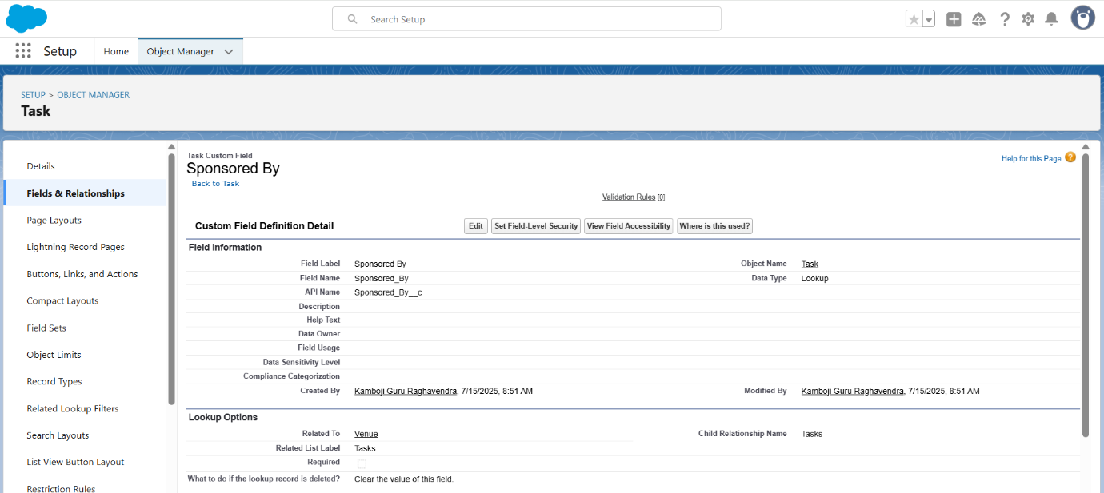

1. Field label: Auto generated
2. Next >> Next >> Save.

Creation of Lookup Relationship Field on Task Object:

1. Go to setup>> click on Object Manager >> type object name(Task) in the search bar >> click on the object.
2. Now click on “Fields & Relationships” >> New
3. Select Lookup relationship

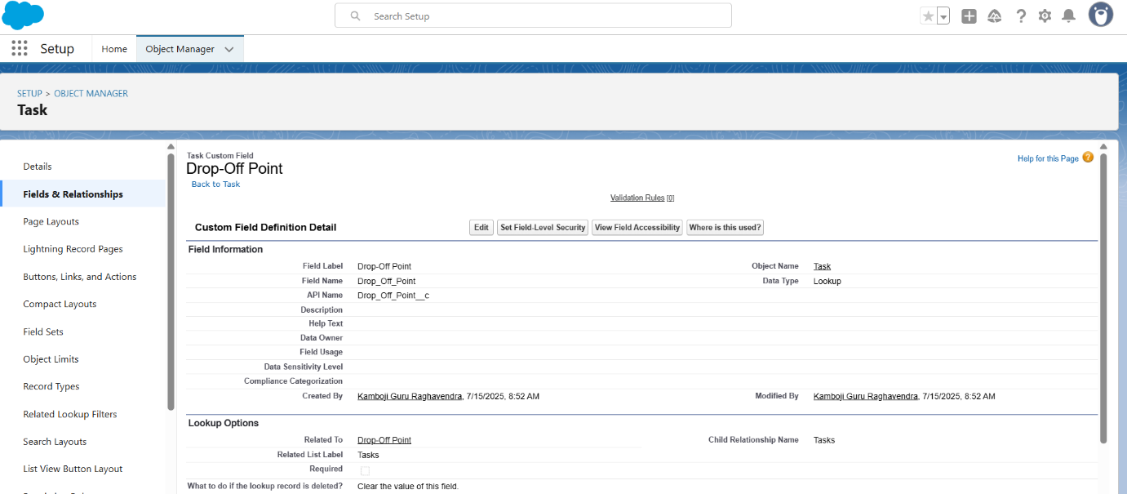

1. Select the related object “Drop-Off point” and click next.
2. Field Name: Drop-Off point
3. Field label: Auto generated
4. Next >> Next >> Save.

**Creation of fields for the Venue object**

1. Go to setup>> click on Object Manager >> type object name(Venue) in search bar >> click on the object.
2. Now click on “Fields & Relationships” >> New
3. Select Data type as a “Email” and Click on Next
4. Fill the Above as following:

* Field Label: Contact Email
* Field Name: Contact Email

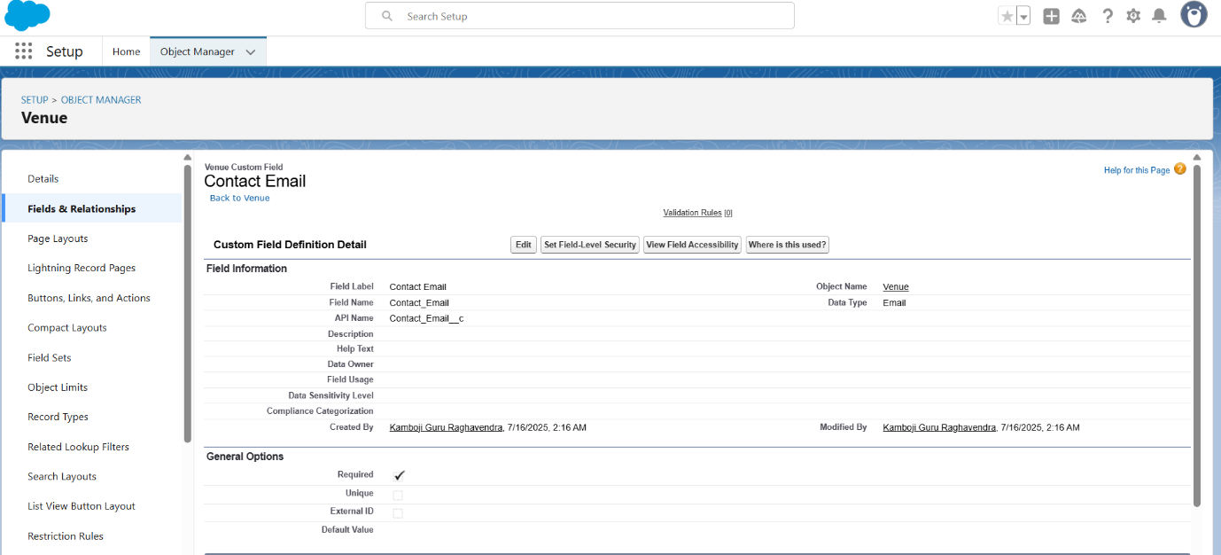

* Click on required check box
* Click on Next >> Next >> Save and new.

**To create another fields in an object:**

1. Go to setup >> click on Object Manager >> type object name(Venue) in search bar >> click on the object.
2. Now click on “Fields & Relationships” >> New
3. Select Data type as a “Phone” and Click on Next

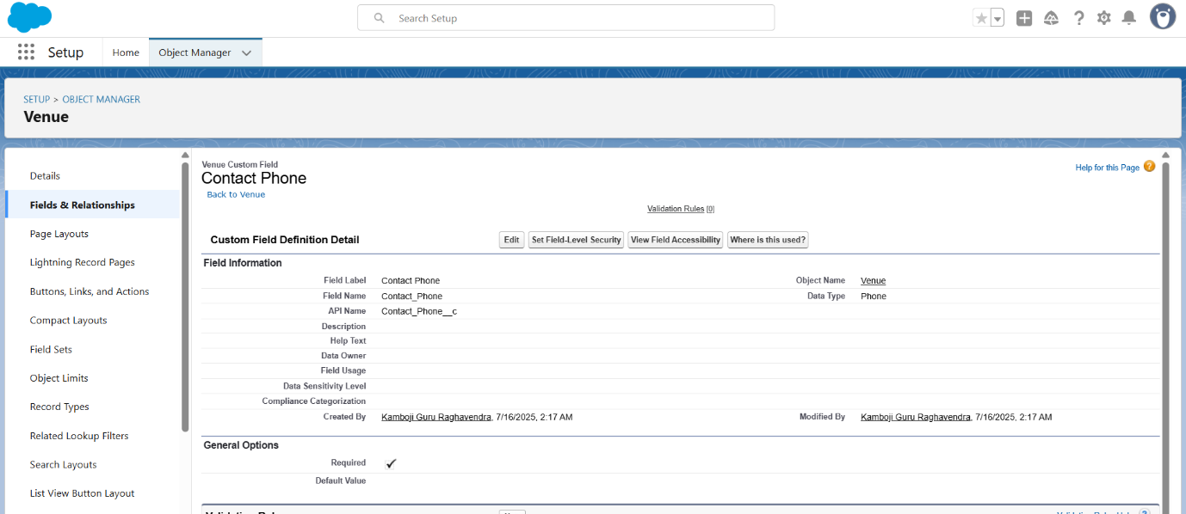

1. Fill the Above as following:

* Field Label: Contact Phone
* Field Name: Contact Phone
* Click on required check box
* Click on Next >> Next >> Save and new.

**To create another fields in an object:**

1. Go to setup >> click on Object Manager >> type object name(Venue) in search bar >>click on the object.
2. Now click on “Fields & Relationships” >> New
3. Select Data type as a “Geolocation” and Click on Next

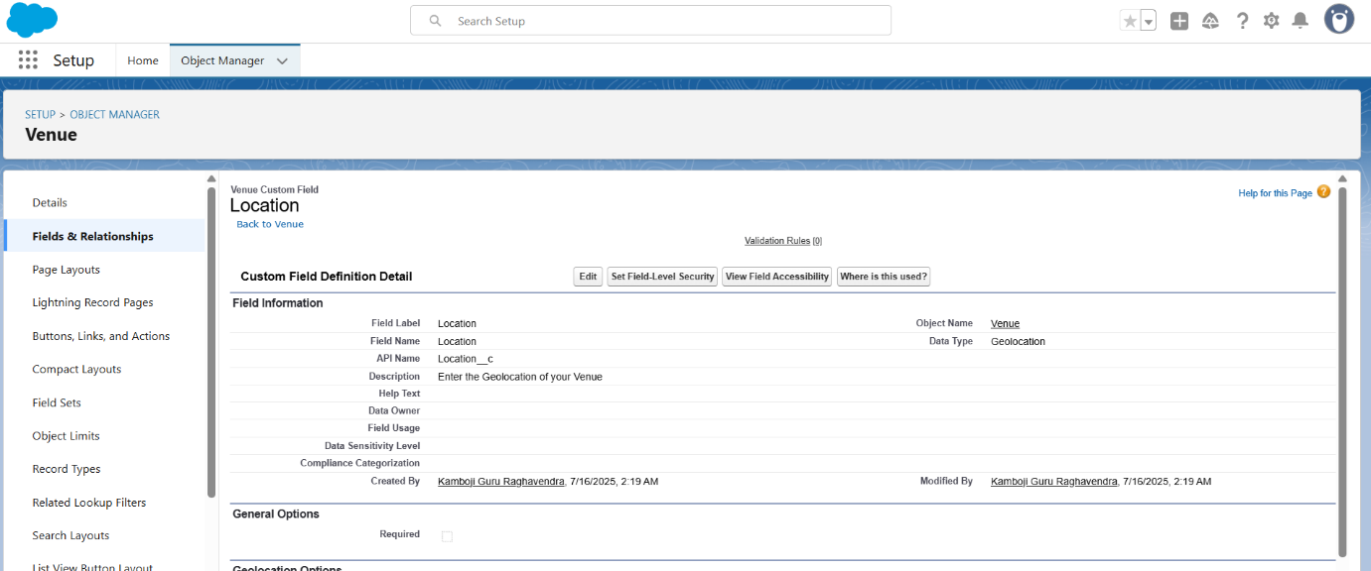

1. Fill the Above as following:

* Field Label: Location
* Decimal Places: 4
* Field Name: Location
* Description: Enter the Geolocation of your Venue
* Click on Next >> Next >> Save and new.

To create other fields in an object:

1. Go to setup >> click on Object Manager >> type object name(Venue) in search bar >> click on the object.
2. Now click on “Fields & Relationships” >> New
3. Select Data type as a “Long Text Area” and Click on Next

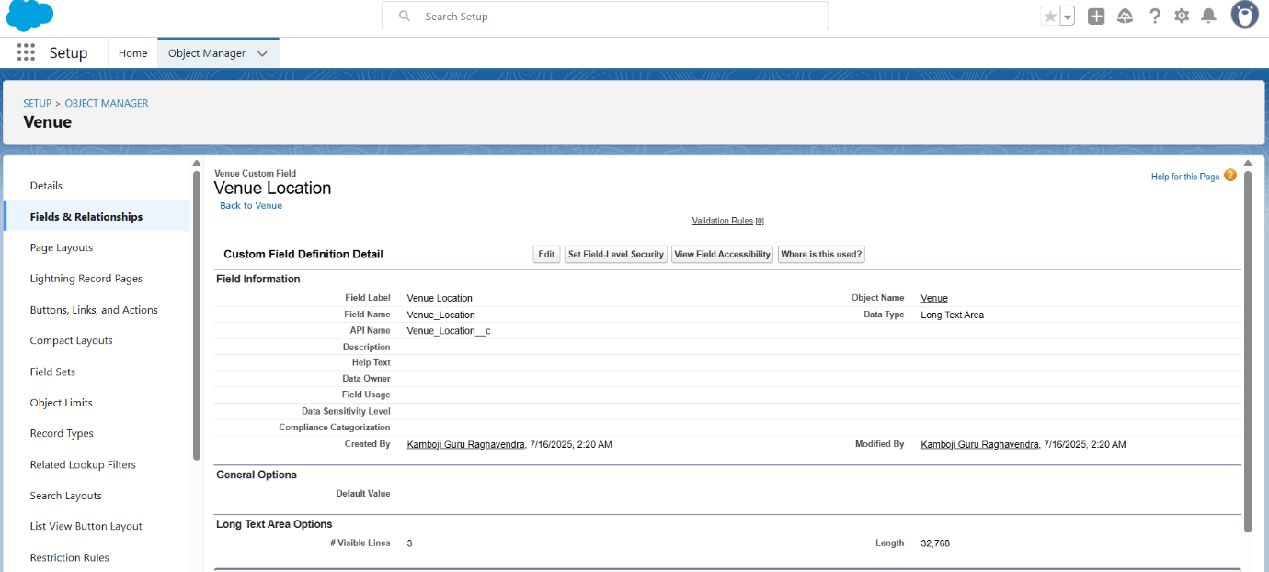

1. Fill the Above as following:

* Field Label : Venue Location
* Field Name : Venue_Location
* Click on Next >> Next >> Save and new.

**Creation of fields for the Drop-Off point object**

Go to setup >> click on Object Manager >> type object name(Drop-Off point) in search bar >> click on the object.

2. Now click on “Fields & Relationships” >> New

3. Select Data type as a “Geolocation” and Click on Next

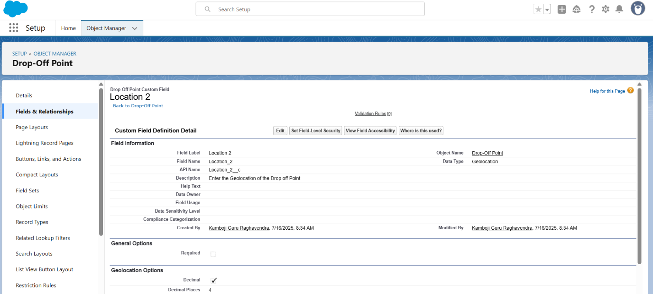

4. Fill the Above as following:

* Field Label: Location 2
* Field Name: gets auto generated
* Description: Enter the Geolocation of the Drop off Point
* Geolocation Options: select Decimal
* Decimal Places: 4
* Click on Next >> Next >> Save and new.

To create another fields in an object:

1. Go to setup >> click on Object Manager >> type object name (Drop-Off point) in search bar >> click on the object.
2. Now click on “Fields & Relationships” >> New
3. Select Data type as a “Formula” and Click on Next

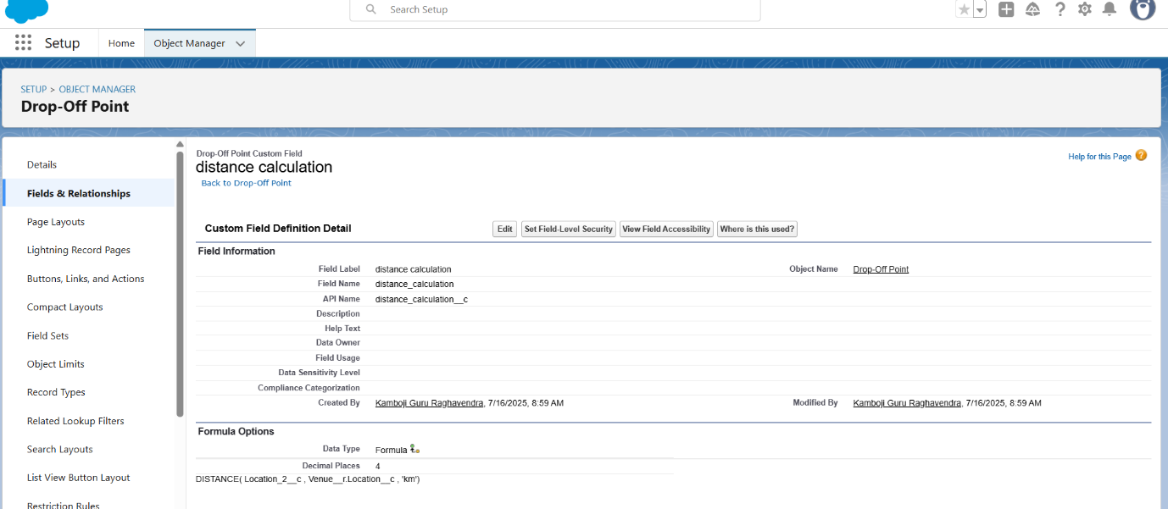

1. Fill the Above as following:

* Field Label: distance calculation
* Field Name: distance_calculation
* Formula Return Type: Number
* Formula Options: DISTANCE( Location_2__c ,  Venue__r.Location__c , 'km')
* Click on Next >> Next >> Save and new.

To create another fields in an object:

1. Go to setup >> click on Object Manager >> type object name (Drop-Off point) in search bar >> click on the object.
2. Now click on “Fields & Relationships” >> New
3. Select Data type as a “Picklist” and Click on Next
4. Fill the Above as following:

* Field Label: State
* Field Name: State
* Enter values, with each value separated by a new line:

Andhra Pradesh

Arunachal Pradesh

Assam

Bihar

Chhattisgarh

Goa

Gujarat

Haryana

Himachal Pradesh

Jharkhand

Karnataka

Kerala

Maharashtra

Madhya Pradesh

Manipur

Meghalaya

Mizoram

Nagaland

Odisha

Punjab

Rajasthan

Sikkim

Tamil Nadu

Tripura

Telangana

Uttar Pradesh

Uttarakhand

West Bengal

Andaman & Nicobar (UT)

Chandigarh (UT)

Dadra & Nagar Haveli and Daman & Diu (UT)

Delhi [National Capital Territory (NCT)]

Jammu & Kashmir (UT)

Ladakh (UT)

Lakshadweep (UT)

Puducherry (UT)

* Click on required check box

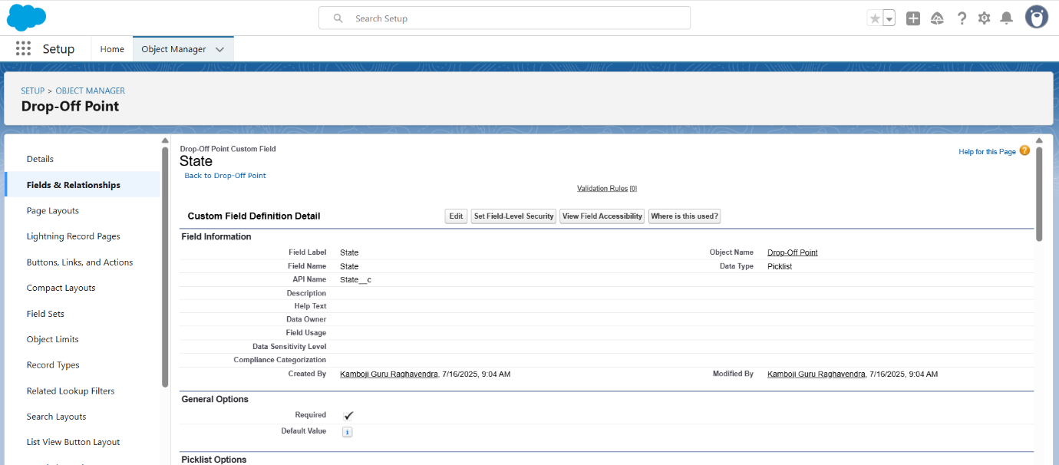

* Click on Next >> Next >> Save and new.

To create another fields in an object:

1. Go to setup >> click on Object Manager >> type object name(Task) in search bar >> click on the object.
2. Now click on “Fields & Relationships” >> New
3. Select Data type as a “Number” and Click on Next

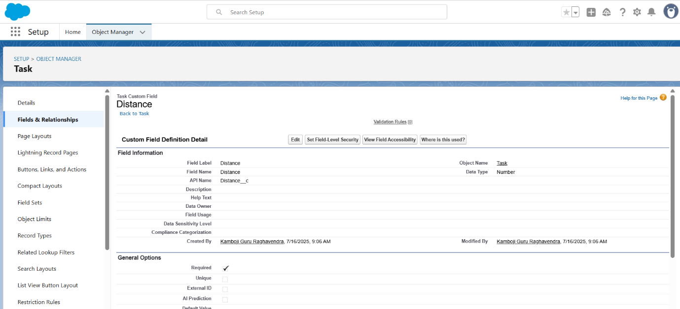

1. Fill the Above as following:

* Field Label: Distance
* Field Name: Distance
* Length: 14
* Decimal Places: 4
* Click on required check box
* Click on Next >> Next >> Save and new.

**Creation of fields for the Task object**

Go to setup>> click on Object Manager >> type object name (Task) in search bar >> click on the object.

2. Now click on “Fields & Relationships” >> New

3. Select Data type as a “Auto Number” and Click on Next

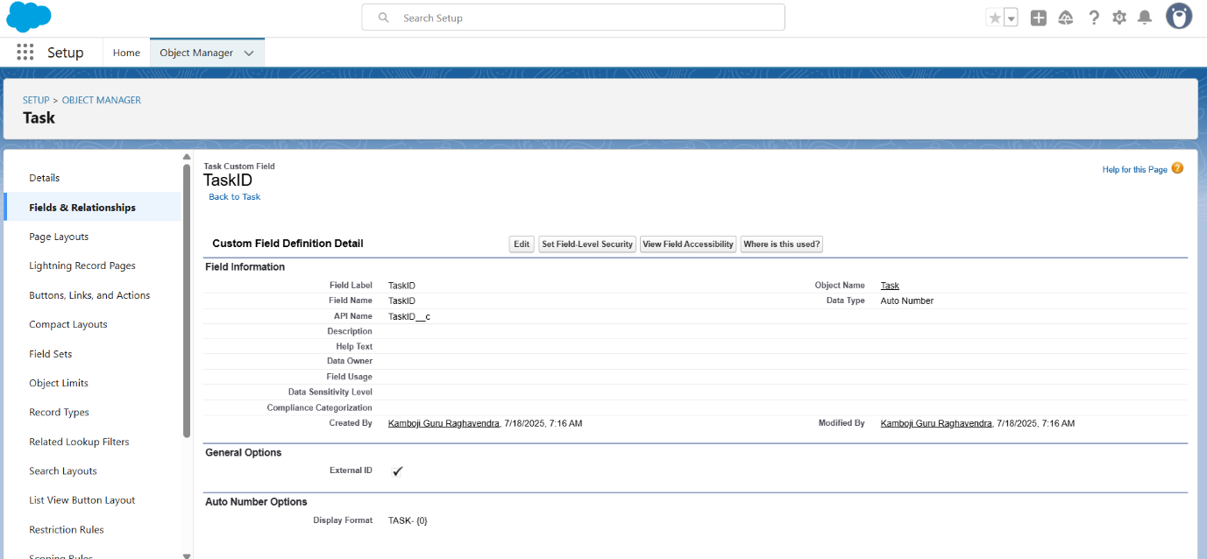

4. Fill the Above as following:

* Field Label: Task ID
* Display Format: TASK- {0}
* Starting Number: 1
* Field Name: gets auto generated
* Click on required check box
* Click on Next >> Next >> Save and new.

To create another fields in an object:

1. Go to setup >> click on Object Manager >> type object name(Task) in search bar >> click on the object.
2. Now click on “Fields & Relationships” >> New
3. Select Data type as a “Date” and Click on Next

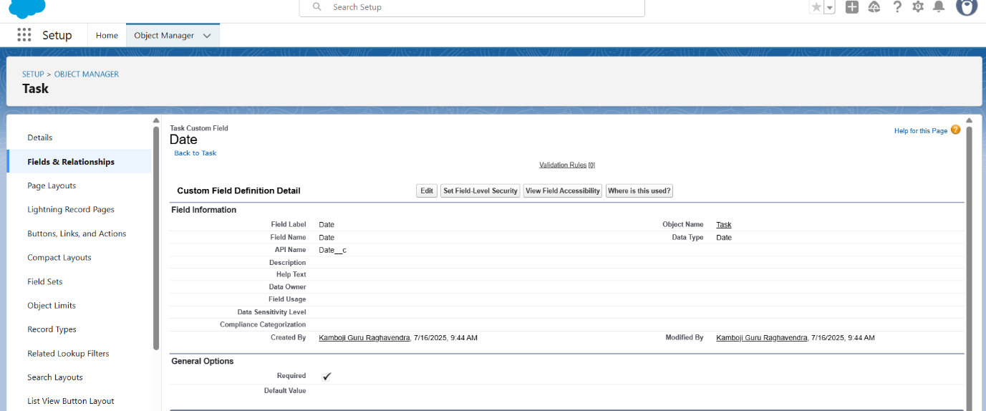

1. Fill the Above as following:

* Field Label: Date
* Field Name: Date
* Click on required check box
* Click on Next >> Next >> Save and new.

To create another fields in an object:

1. Go to setup >> click on Object Manager >> type object name (Task) in search bar >> click on the object.
2. Now click on “Fields & Relationships” >> New
3. Select Data type as a “Picklist (Multi-Select)” and Click on Next

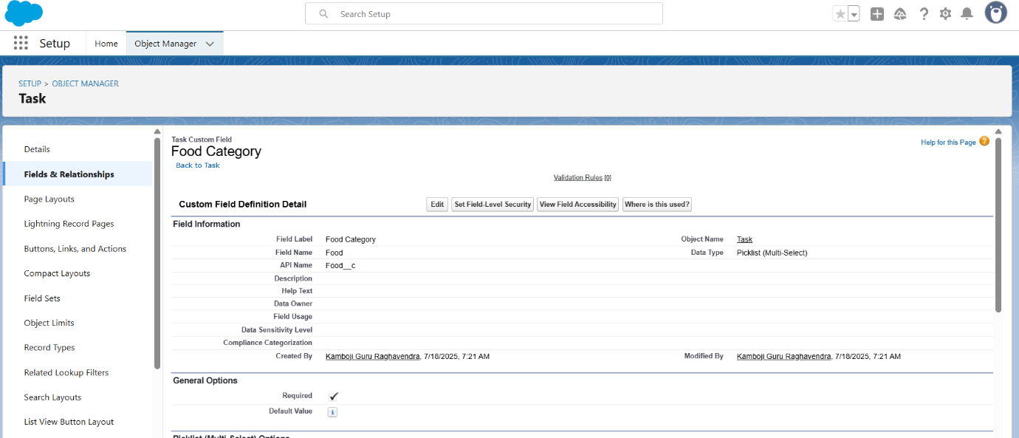

1. Fill the Above as following:

* Field Label: Food Category
* Field Name: Food Category
* Enter values, with each value separated by a new line :

Veg

Non-Veg

Salad

Snack

* Click on required check box
* Click on Next >> Next >> Save and new.

To create another fields in an object:

1. Go to setup >> click on Object Manager >> type object name(Task) in search bar >> click on the object.
2. Now click on “Fields & Relationships” >> New
3. Select Data type as a “Number” and Click on Next

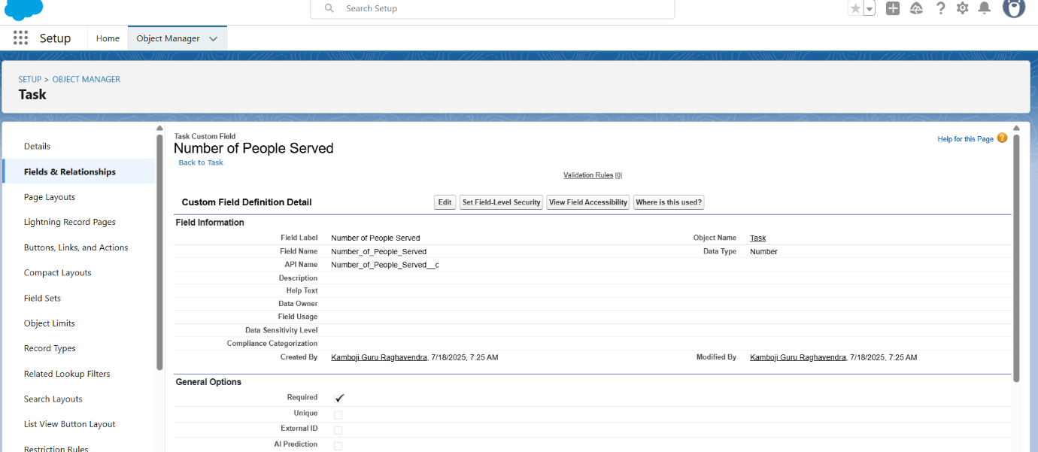

1. Fill the Above as following:

* Field Label: Number of People Served
* Field Name: Number_of_People_Served
* Click on required check box
* Click on Next >> Next >> Save and new.

To create another fields in an object:

1. Go to setup >> click on Object Manager >> type object name(Task) in search bar >> click on the object.
2. Now click on “Fields & Relationships” >> New
3. Select Data type as a “Text” and Click on Next

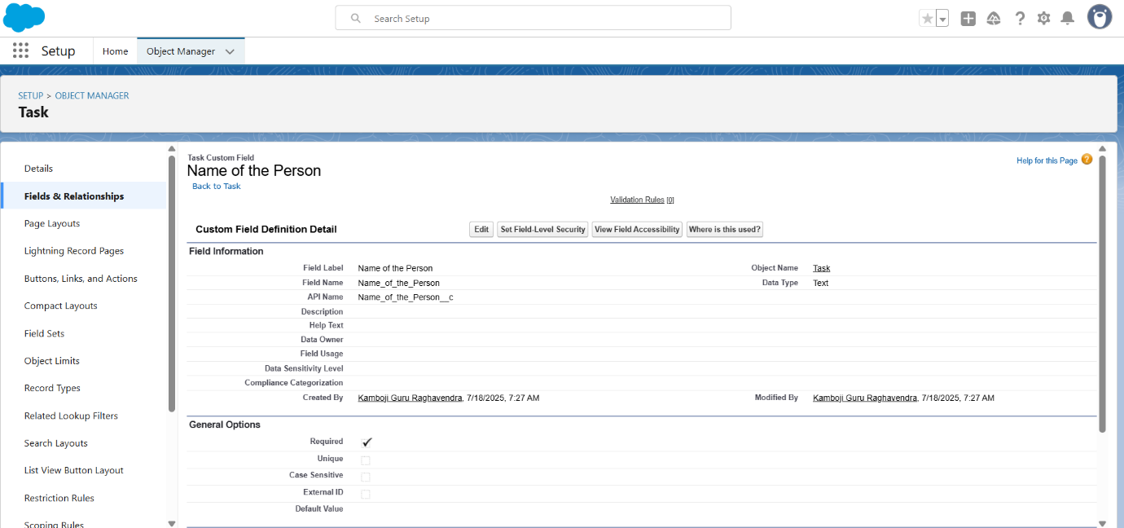

1. Fill the Above as following:

* Field Label: Name of the Person
* Field Name: Name_of_the_Person
* Click on Next >> Next >> Save and new.

To create another fields in an object:

1. Go to setup>> click on Object Manager >> type object name(Task) in search bar >> click on the object.
2. Now click on “Fields & Relationships” >> New
3. Select Data type as a “Phone” and Click on Next

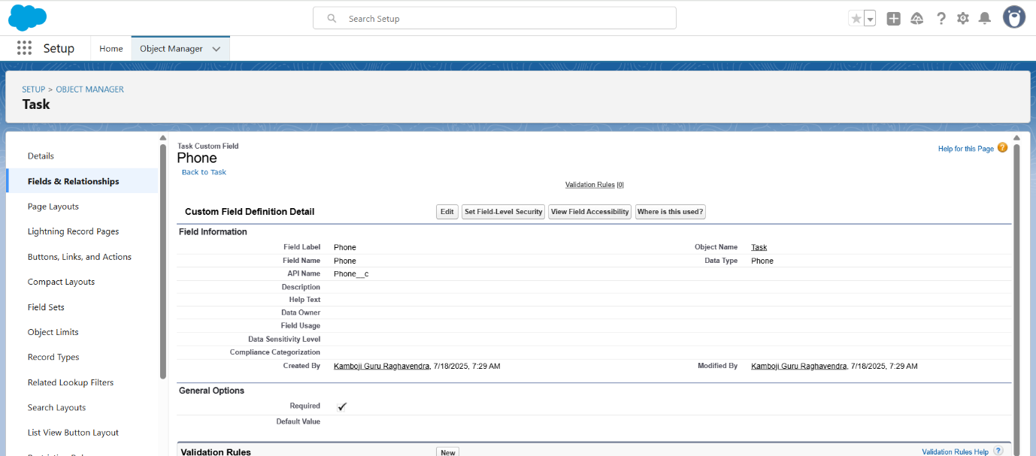

1. Fill the Above as following:

* Field Label: Phone
* Field Name: Phone
* Click on Next >> Next>> Save and new.

To create another fields in an object:

1. Go to setup >> click on Object Manager >> type object name(Task) in search bar >> click on the object.
2. Now click on “Fields & Relationships” >> New
3. Select Data type as a “Pick List” and Click on Next

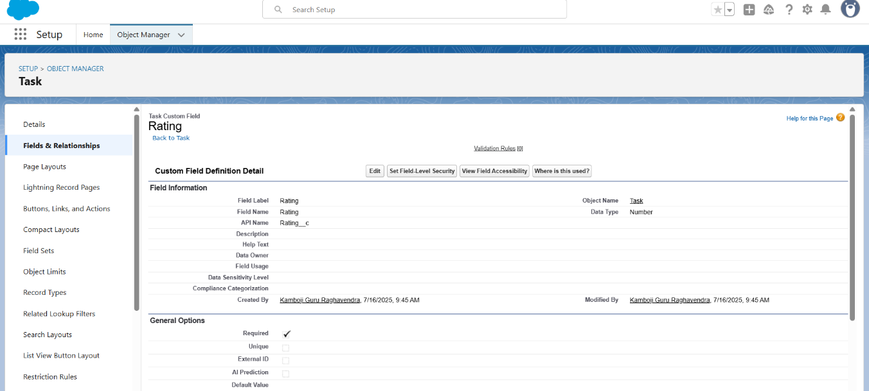

1. Fill the Above as following:

* Field Label: Rating
* Field Name: Rating
* Enter values, with each value separated by a new line:

1

2

3

4

5

* Click on Next >> Next >> Save and new.

To create another fields in an object:

1. Go to setup >> click on Object Manager >> type object name (Task) in search bar >> click on the object.
2. Now click on “Fields & Relationships” >> New
3. Select Data type as a “Long Text Area” and Click on Next

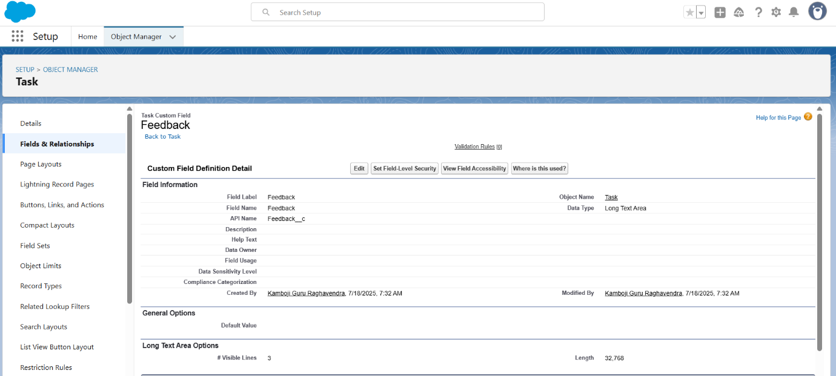

1. Fill the Above as following:

* Field Label: Feedback
* Field Name: Feedback
* Click on Next >> Next >> Save and new.

**Creation of fields for the Task object**

Go to setup>> click on Object Manager >> type object name(Task) in search bar >> click on the object.

2. Now click on “Fields & Relationships” >> New

3. Select Data type as a “Auto Number” and Click on Next

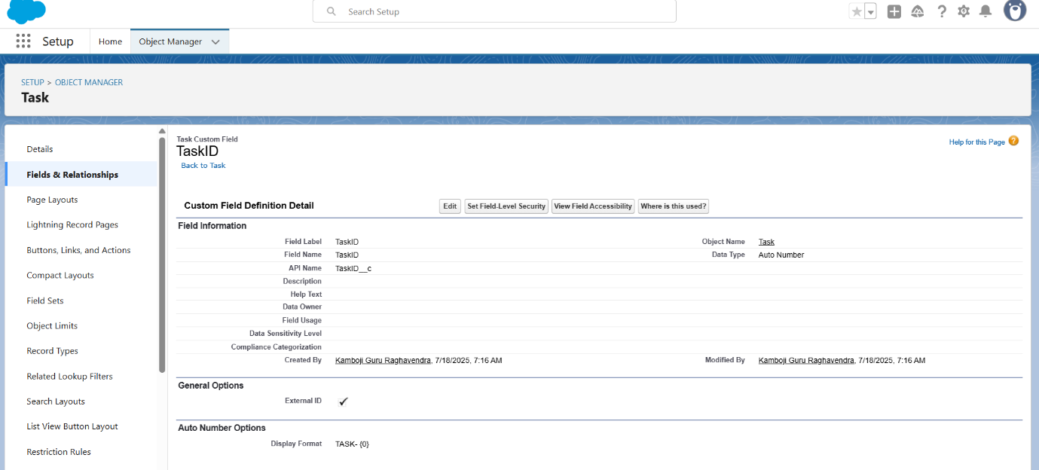

4. Fill the Above as following:

* Field Label: Task ID
* Display Format: TASK-{0}
* Starting Number: 1
* Field Name: gets auto generated
* Click on required check box
* Click on Next >> Next >> Save and new.

To create another fields in an object:

1. Go to setup >> click on Object Manager >> type object name(Task) in search bar >> click on the object.
2. Now click on “Fields & Relationships” >> New
3. Select Data type as a “Date” and Click on Next

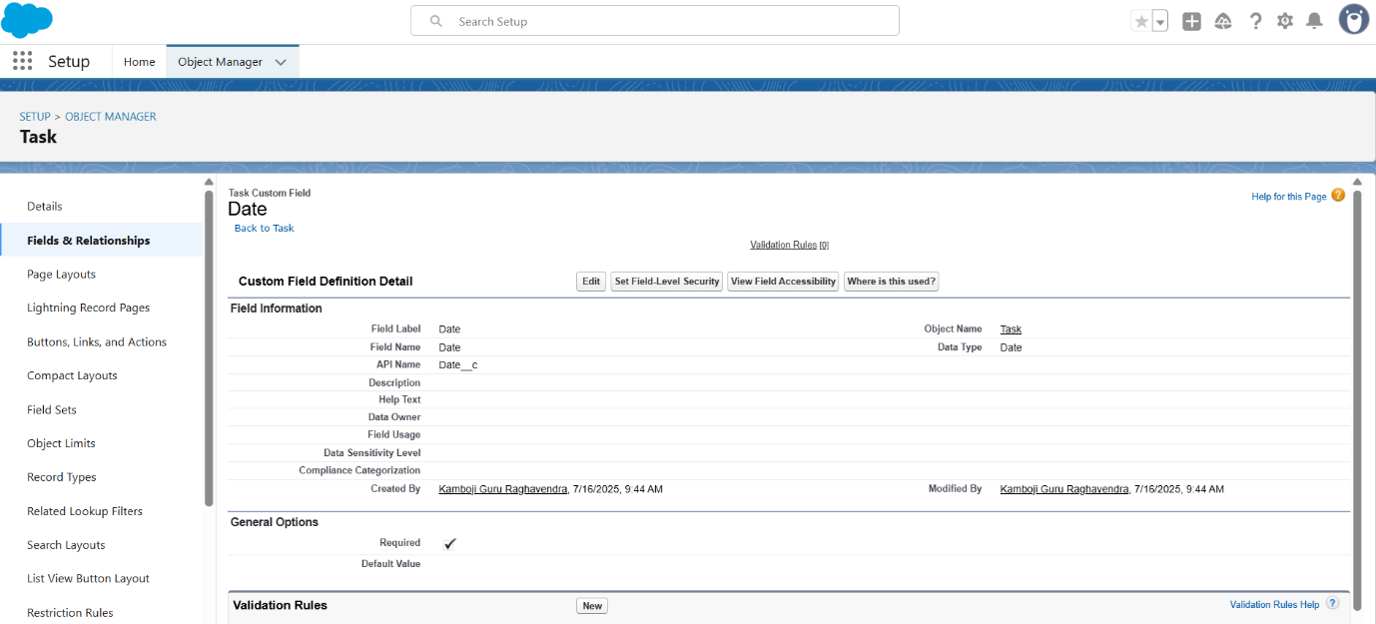

1. Fill the Above as following:

* Field Label: Date
* Field Name: Date
* Click on required check box
* Click on Next >> Next >> Save and new.

To create another fields in an object:

1. Go to setup >> click on Object Manager >> type object name(Task) in search bar >> click on the object.
2. Now click on “Fields & Relationships” >> New
3. Select Data type as a “Picklist (Multi-Select)” and Click on Next
4. Fill the Above as following:

* Field Label: Food Category
* Field Name: Food Category
* Enter values, with each value separated by a new line:

Veg

Non-Veg

Salad

Snack

* Click on required check box
* Click on Next >> Next >> Save and new.

To create another fields in an object:

1. Go to setup >> click on Object Manager >> type object name (Task) in search bar >> click on the object.
2. Now click on “Fields & Relationships” >> New
3. Select Data type as a “Number” and Click on Next
4. Fill the Above as following:

* Field Label: Number of People Served
* Field Name: Number_of_People_Served
* Click on required check box
* Click on Next >> Next >> Save and new.

To create another fields in an object:

1. Go to setup >> click on Object Manager >> type object name(Task) in search bar >> click on the object.
2. Now click on “Fields & Relationships” >> New
3. Select Data type as a “Text” and Click on Next
4. Fill the Above as following:

* Field Label: Name of the Person
* Field Name: Name_of_the_Person
* Click on Next >> Next >> Save and new.

To create another fields in an object:

1. Go to setup>> click on Object Manager >> type object name(Task) in search bar >> click on the object.
2. Now click on “Fields & Relationships” >> New
3. Select Data type as a “Phone” and Click on Next
4. Fill the Above as following:

* Field Label: Phone
* Field Name: Phone
* Click on Next >> Next>> Save and new.

To create another fields in an object:

1. Go to setup >> click on Object Manager >> type object name(Task) in search bar >> click on the object.
2. Now click on “Fields & Relationships” >> New
3. Select Data type as a “Pick List” and Click on Next
4. Fill the Above as following:

* Field Label: Rating
* Field Name: Rating
* Enter values, with each value separated by a new line:

1

2

3

4

5

* Click on Next >> Next >> Save and new.

To create another fields in an object:

1. Go to setup >> click on Object Manager >> type object name (Task) in search bar >> click on the object.
2. Now click on “Fields & Relationships” >> New
3. Select Data type as a “Long Text Area” and Click on Next

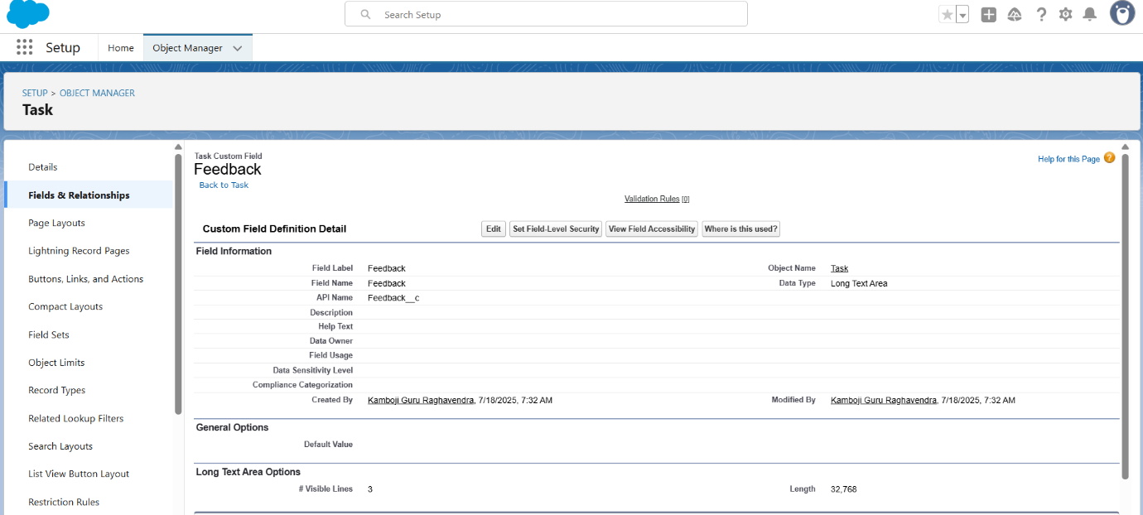

1. Fill the Above as following:

* Field Label: Feedback
* Field Name: Feedback
* Click on Next >> Next >> Save and new.

**Creation of fields for the Execution Details object**

1.Go to setup >> click on Object Manager >> type object name (Volunteer) in search bar >> click on the object.

2. Now click on “Fields & Relationships” >> New

3. Select Data type as a “Auto Number” and Click on Next

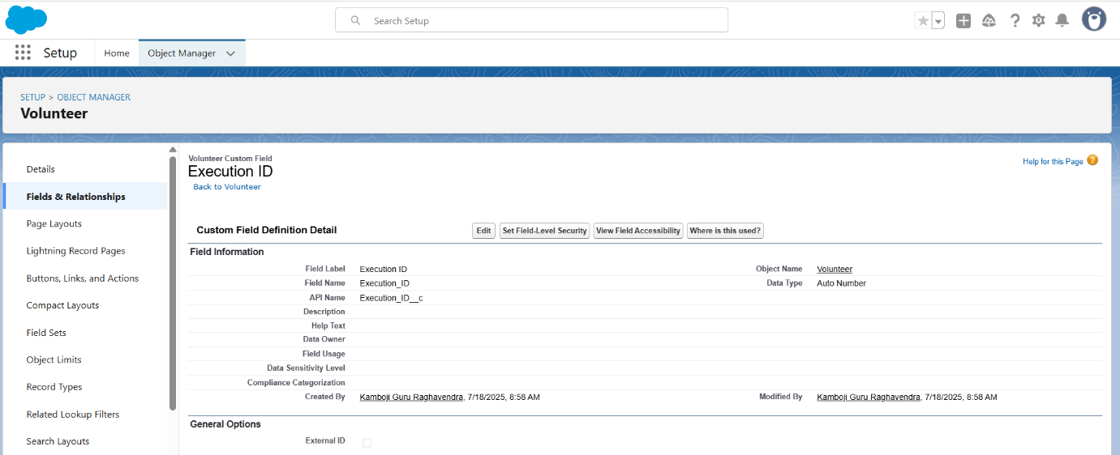

4. Fill the Above as following:

* Field Label: Execution ID
* Field Name: gets auto generated
* Click on required check box
* Click on Next >> Next >> Save and new.

**Create Flow to create a record in Venue object**

1. Go to setup >> type Flow in quick find box >> Click on the Flow and Select the New Flow.
2. Select the Screen flow. Click on create.
3. Click on the ‘+’ icon in between start and end and click on screen element.
4. Under the Screen Properties:

Label: Venue Details

API Name: Venue_Details

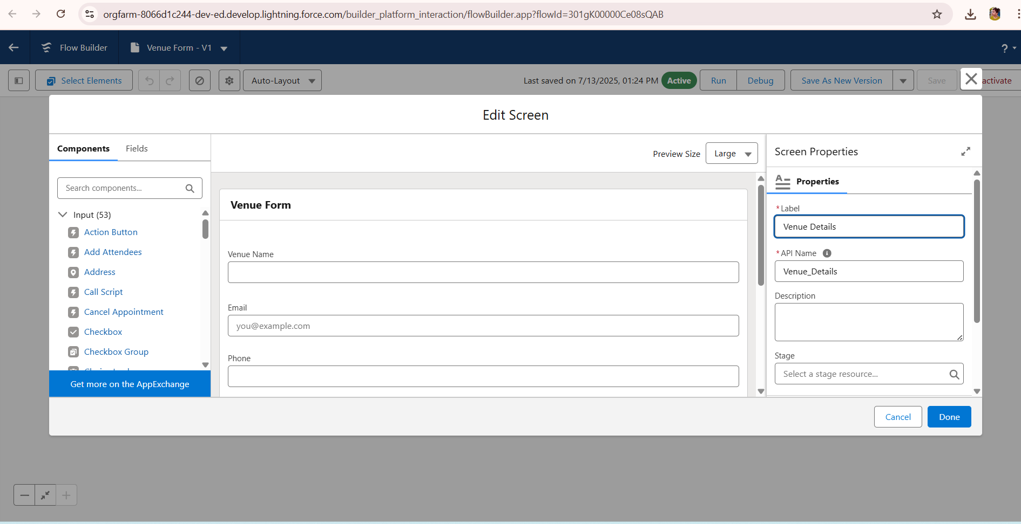

1. Now let’s add components in this flow. Click on Text Component and name it as:

Label: Venue Name

API Name: Venue_Name

1. Click on Email Component and name it as:

Label: Email

API Name: Contact_Email

1. Click on Phone Component and name it as:

Label: Phone

API Name: Contact_Phone

1. Click on Text Component and name it as:

Label: Venue Location

API Name: Venue_Location

1. Click on Number Component and name it as:

Label: Latitude

API Name: Latitude

1. Click on Number Component and name it as:

Label: longitude

API Name: longitude

1. Next click on Done. This would like below
2. Click on the ‘+’ icon in between Venue details and end and click on create record element.
3. Now label it as

Label: Create Venue Record

API Name: Create_Venue_Record

How Many Records to Create: One

How to Set the Record Fields: Use separate resources, and literal values

Object: Venue

Set Field Values for the Venue: Click on ‘Add Field’ 5 times

Field: Value = Contact_Email__c : {! Contact_Email.value}

Field: Value = Contact_Phone__c : {! Contact_Phone.value}

Field: Value = Name: {! Venue Name}

Field: Value = Venue_Location__c : {! location}

Field: Value = Location__Latitude__s : {! latitude}

Field: Value = Location__Longitude__s : {!longitude}

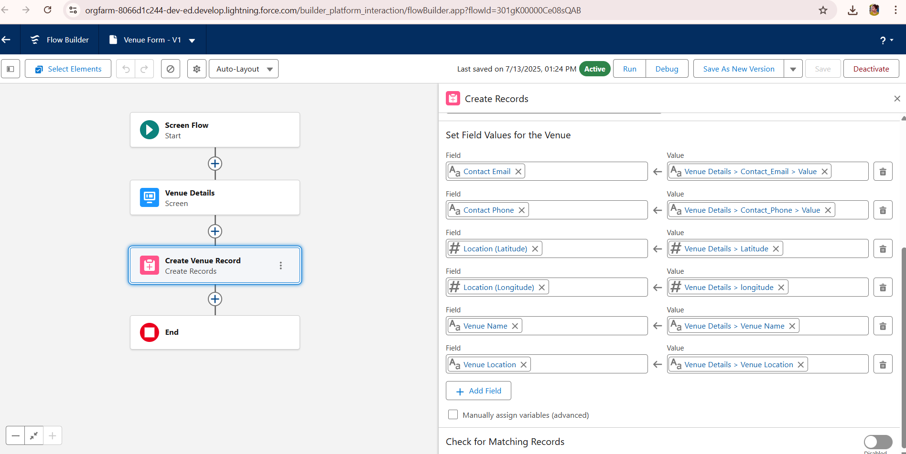

1. This would look like:
2. Click on Save as:

Flow Label: Venue Form

Flow API Name: Venue_Form

**Apex Classes, Triggers, Asynchronous Apex:**

Custom Apex triggers were developed to automatically update stock status and generate distribution records when a pickup is marked completed. Additionally, asynchronous Apex (Batch Apex) was implemented to periodically send summary emails to donors and NGOs highlighting food saved and beneficiaries served over the week. This ensures timely communication and promotes continued engagement without impacting real-time system performance.

**Create a Trigger**

1. Log into the trailhead account, navigate to the gear icon in the top right corner.
2. Click on developer console and you will be navigated to a new console window.
3. Click on the File menu in the toolbar and click on new >> Trigger.
4. Enter the trigger name and the object to be triggered.

1. Enter Name: DropOffTriggers
2. Object: Drop-Off Point
3. Click on Submit.

**Trigger Code**

(This Trigger is to assign Distance field to the Distance Calculation field. So that we can assign the distance in the sharing rules.)

**Code:**

trigger DropOffTrigger on Drop_Off_point__c (before insert) {

    for(Drop_Off_point__c Drop : Trigger.new){

        Drop.Distance__c = Drop.distance_calculation__c;

    }

}

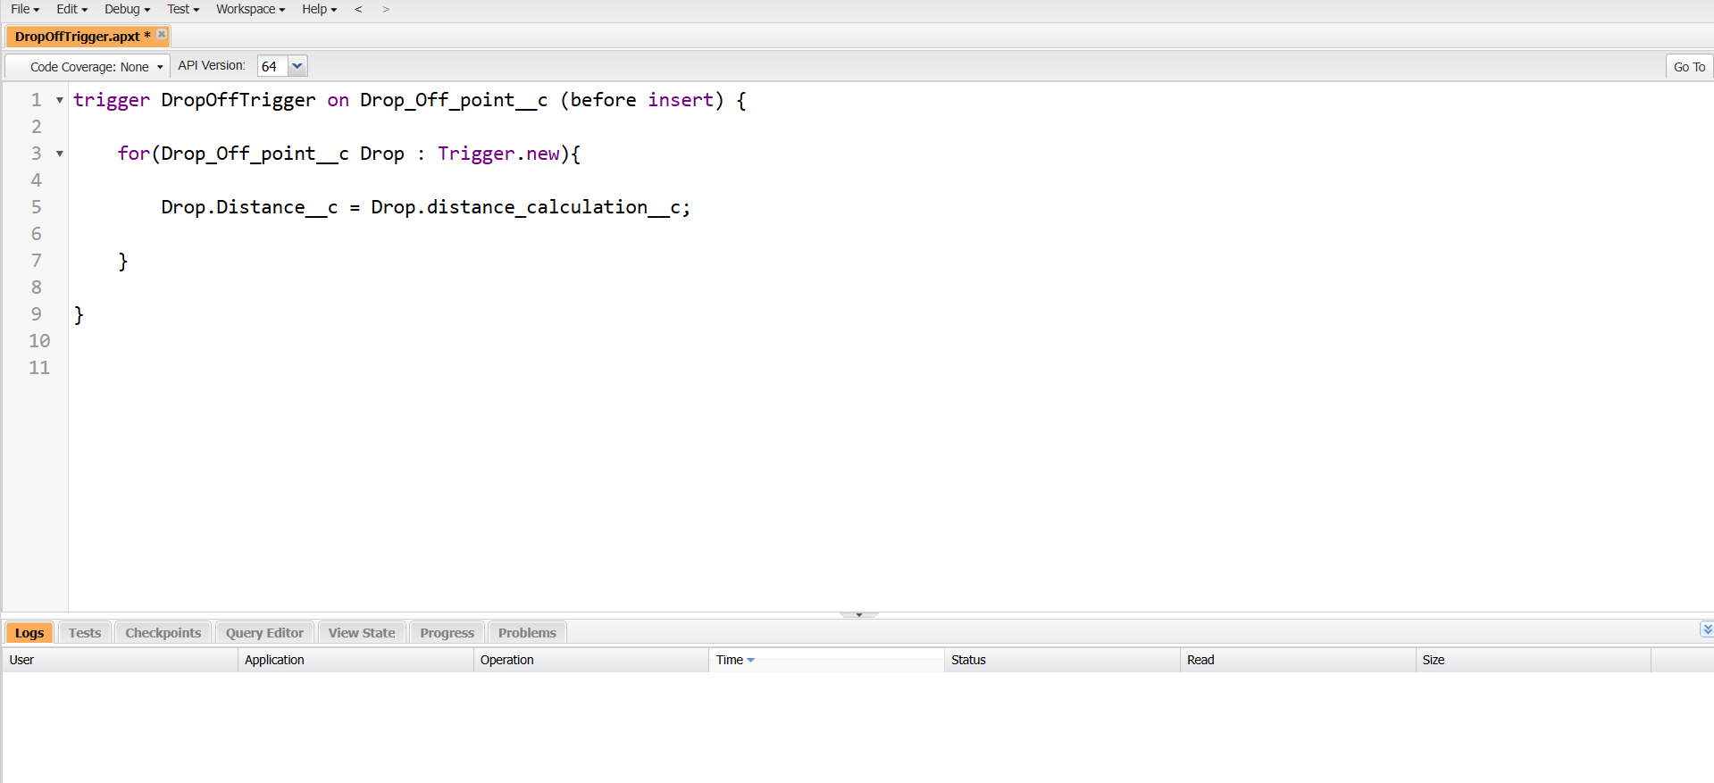

**Phase 3:UI/UX Development & Customization:**

**Create a Lightning App**

To create a lightning app page:

1. Go to setup page >> search “app manager” in quick find >> select “app manager” >> click on new lightning App.

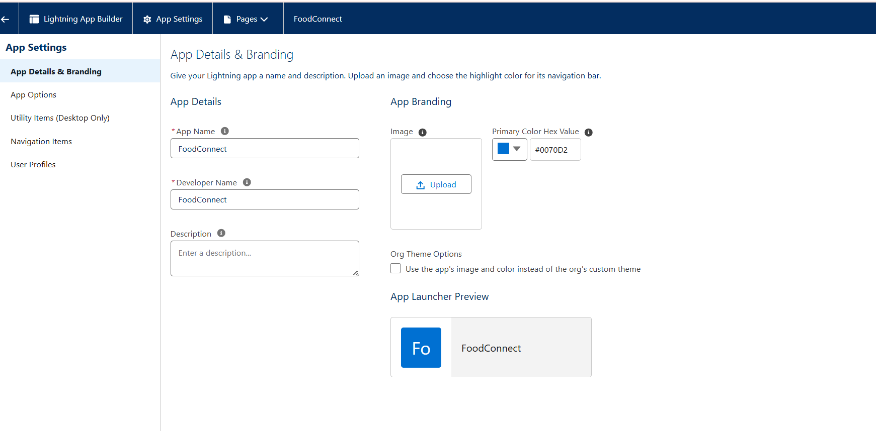

2. Fill the app name in app details and branding as follow App

Name:FoodConnect  
Developer_Name:Thiswillautopopulated  
Image : optional (if you want to give any image you can otherwise not mandatory) Primary color hex value : keep this default.

3.Then click Next  >> (App option page)Set Navigation Style as Standard Navigation >> Next.

4. (Utility Items) keep it as default >> Next.  
5. To Add Navigation Items:

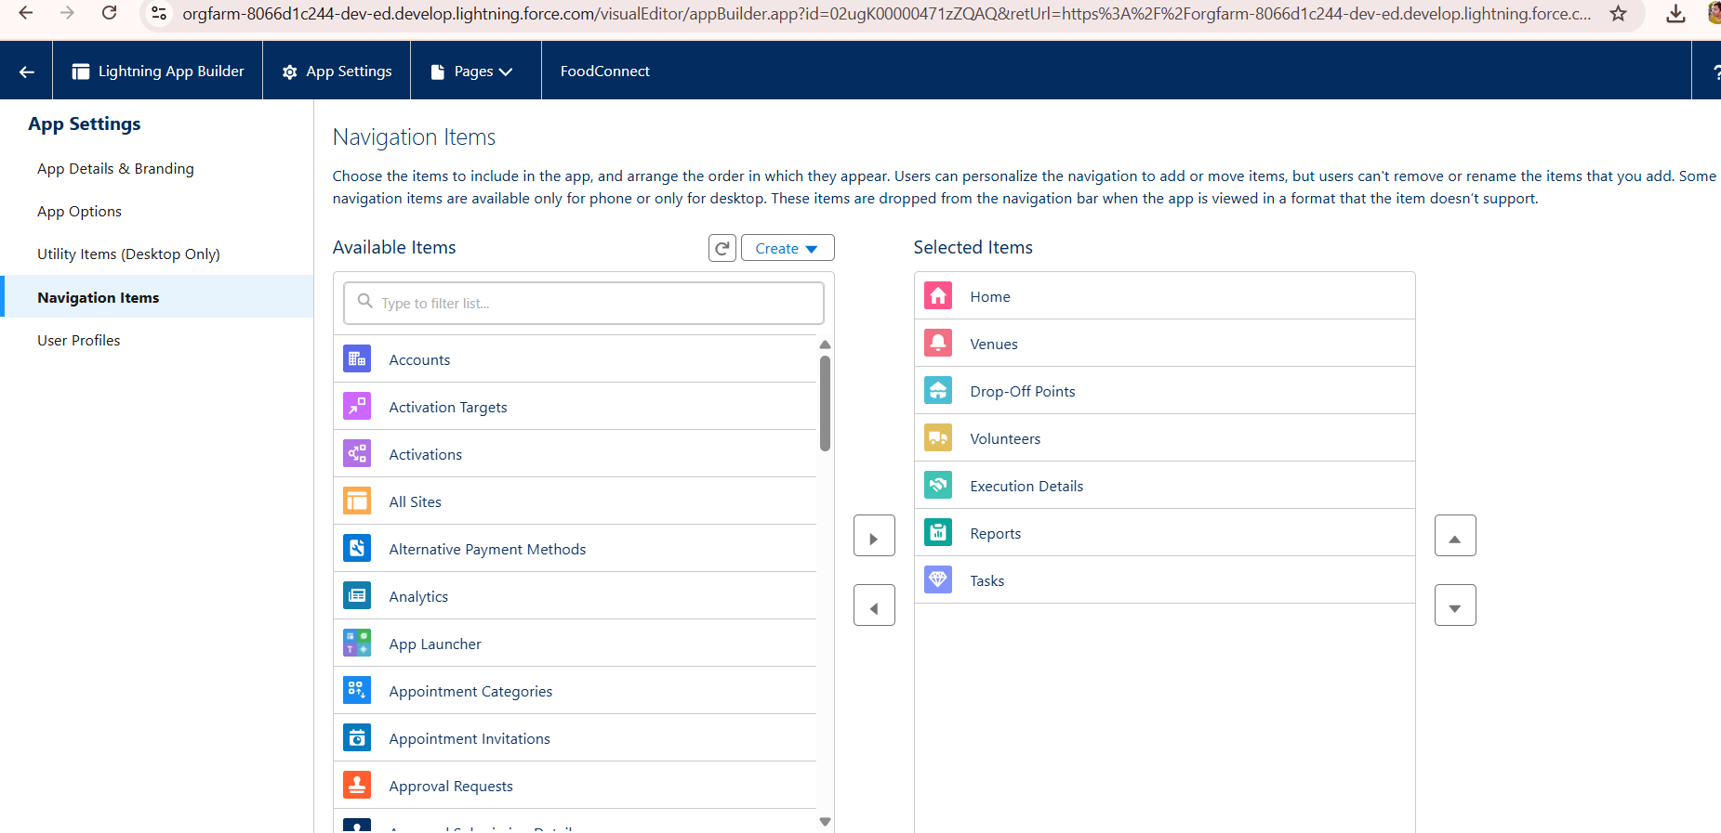

Search for the item in the (Home, Venue, Drop-Off Point, Task, Volunteer, Execution Details, Reports) from the search bar and move it using the arrow button >> Next >> Next.

6. To Add User Profiles:

Search profiles (System administrator) in the search bar >> click on the arrow button >> save & finish.

**Creation of Report on Venue with DropOff with Volunteer**

1. Go to the app (FoodConnect)  >>  click on the reports tab
2. Click on New Folder.

Folder Label: Custom Reports

Folder Unique Name: CustomReports

1. Open Custom Reports and click on New Report
2. Select Report Type: Venue with DropOff with Volunteer
3. Then click on Start Report.
4. In GROUP ROWS: Add Volunteer Name
5. In Columns: Add Venue Name, Drop-Off point Name, Distance.

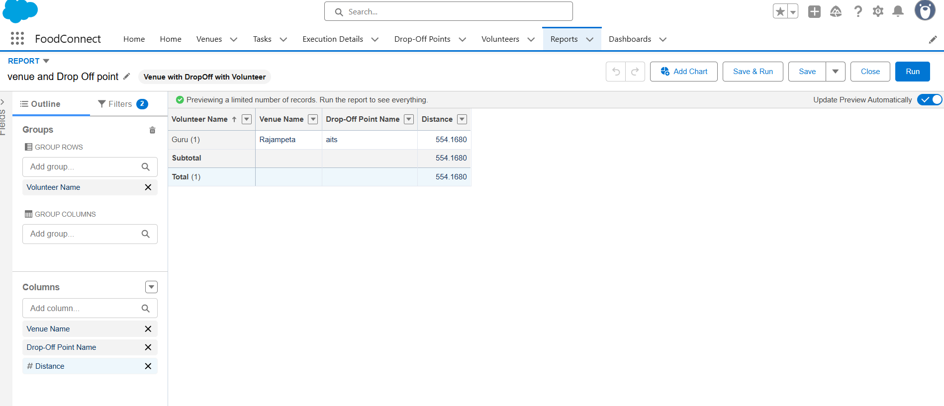

1. Now click on Save & Run.
2. Give Label as:
3. Report Name: venue and Drop Off point
4. Report Unique Name: Auto Populated
5. Click on Select Folder and select Custom Report, then click on Save.

**Creation of Report on Volunteers with Execution Details and Tasks**

1. Go to the app (FoodConnect)  >>  click on the reports tab
2. Click on Custom Reports Folder and click on New Report
3. Select Report Type: Volunteers with Execution Details and Tasks.
4. Then click on Start Report.
5. In GROUP ROWS: Volunteer ID
6. In Columns: Add Volunteer: Volunteer Name, Task: Task Name, Execution Detail : Execution Detail Name, Volunteer: Owner Name, Task: Date, Task : Rating.

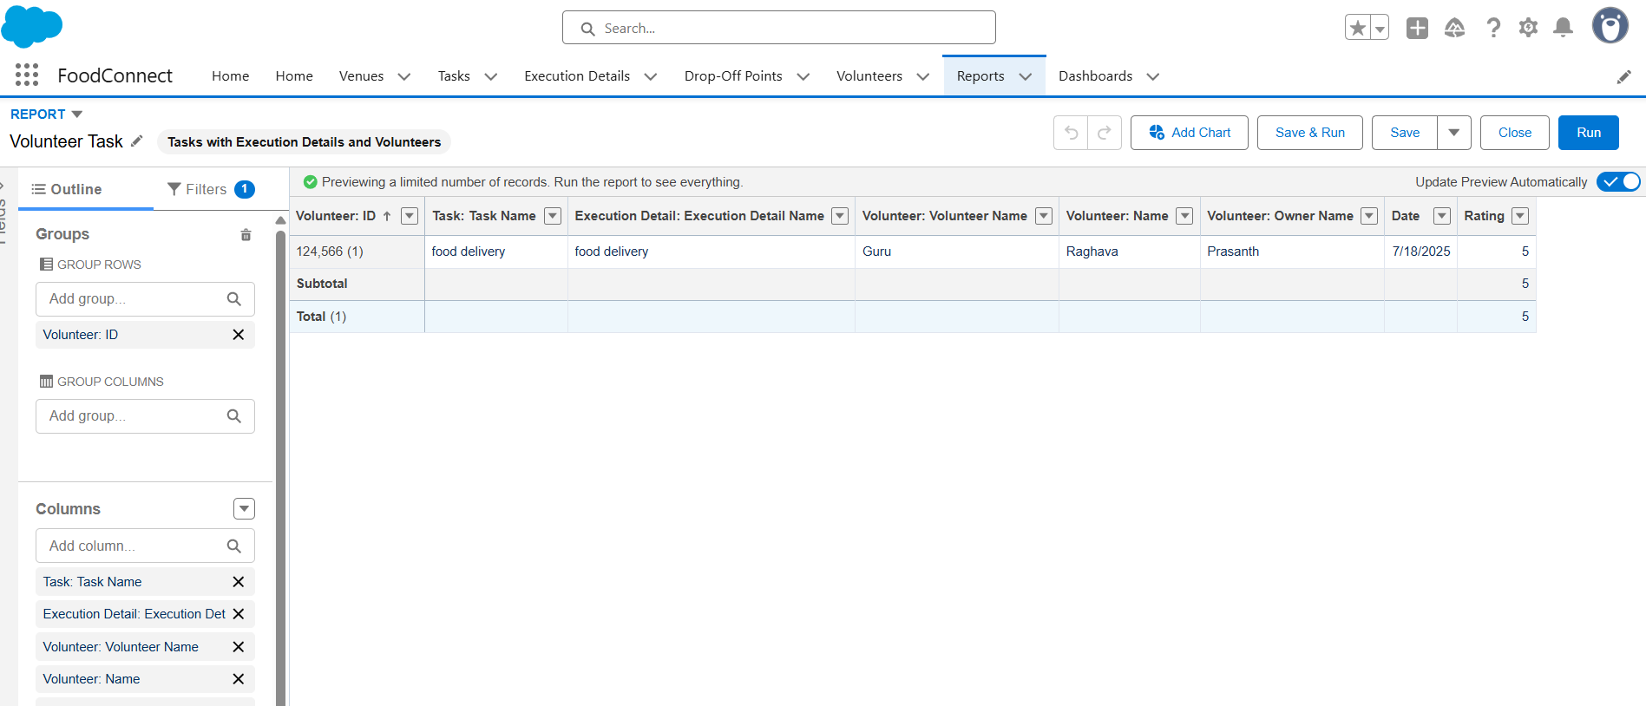

1. Now click on Save & Run.
2. Give Label as:

Report Name: Volunteer Task

Report Unique Name: Auto Populated

1. Click on Select Folder and select Custom Report, then click on Save.

**Adding venue and Drop Off point Report to the Dashboard**

1. Go to the app (Food Connect) >>  click on the Dashboards tab.
2. Click on New Folder.

Folder Label: Custom Dashboards

Folder Unique Name: Auto Populated

1. Open Custom Dashboards and click on New Dashboards
2. Name: Organization Details
3. Click on Widget and select Chart or Table
4. In Select Report: Select venue and Drop Off point Report.
5. Then click on select
6. In Add Component:

Display As: Select Lightning Table

Component Theme: Select Dark (Optional)

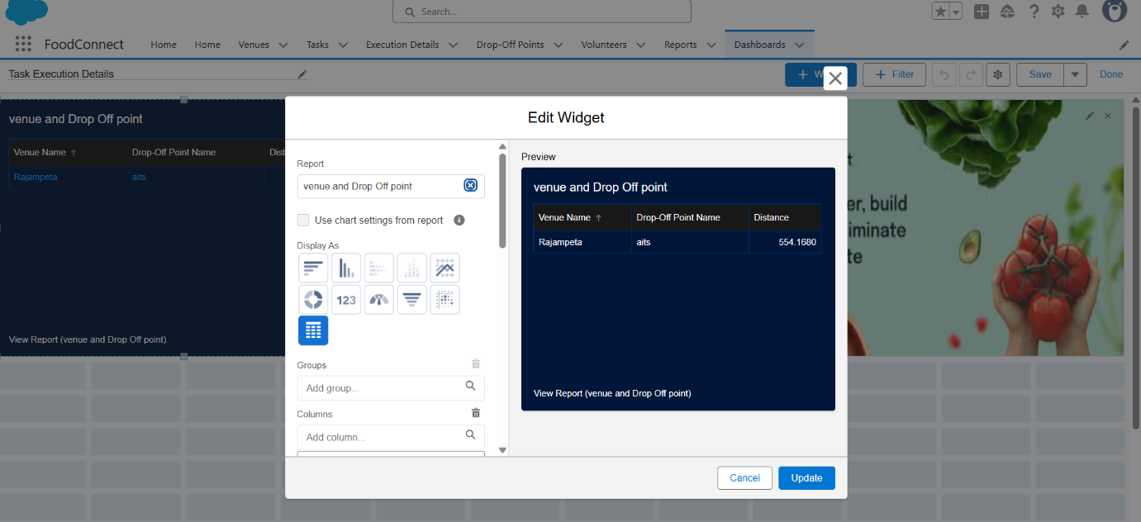

1. Now click on save.

**Adding Volunteer Task Report to the Dashboard**

1. Click on Widget and select Chart or Table
2. In Select Report: Select Volunteer Task Report.
3. Then click on select
4. In Add Component:

Display As: Select Line Chart

Component Theme: Select Dark (Optional)

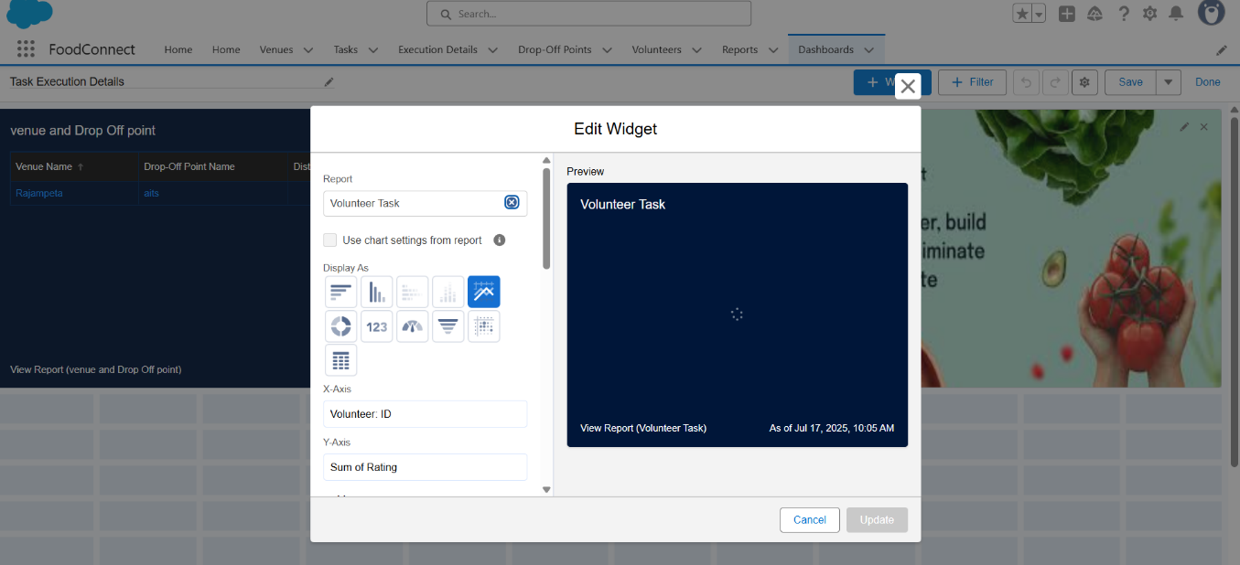

1. Now click on save.

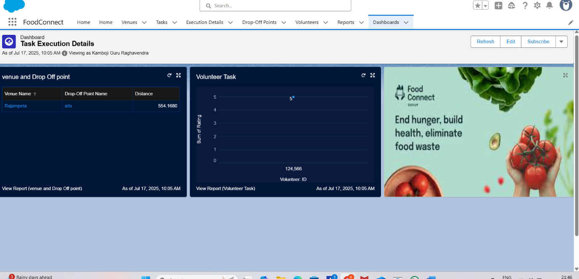

**Phase 4: Data Migration, Testing & Security**

**Data Loading Process:**

Historical data of partner restaurants, NGOs, and past donation records was migrated into Salesforce using the Data Loader, chosen for its capability to handle bulk records and ensure referential integrity across custom objects like Food Donation, Pickup Schedule, and Distribution Record. This ensured a smooth transition from manual tracking systems to the new automated CRM.

**Field History Tracking, Duplicate Rules, Matching Rules:**

Field History Tracking was enabled on key objects such as Food Donation and Pickup Schedule to maintain an audit trail of critical changes like pickup time adjustments or status updates. Duplicate Rules and Matching Rules were configured on the Donor and Recipient records to prevent redundant entries and ensure that every partner is uniquely identified, thereby preserving data quality.

**Profiles, Roles, Role Hierarchy, Permission Sets, Sharing Rules:**

A robust security model was implemented using Salesforce Profiles and Roles. Profiles controlled baseline access for different users like restaurant managers, NGO coordinators, and volunteer drivers. A Role Hierarchy was established to allow NGO managers to view records of volunteers under them while keeping data compartmentalized across different NGOs. Permission Sets were used to grant additional privileges, such as access to dashboards for analytics teams, while Sharing Rules ensured specific records (like a Pickup Schedule) could be shared with relevant volunteers automatically.

**Profiles**

1. Go to setup page >> type Profiles in Quick Find bar >> click on Profiles >> click on ‘S’
2. Click on Clone beside Standard Platform User.
3. Under Clone Profile:

Profile Name: NGOs Profile

4. Then click on Save

**Profiles**

1. Go to setup page >> type Profiles in Quick Find bar >> click on Profiles >> click on ‘S’
2. Click on Clone beside Standard Platform User.
3. Under Clone Profile:

Profile Name: NGOs Profile

4. Then click on Save

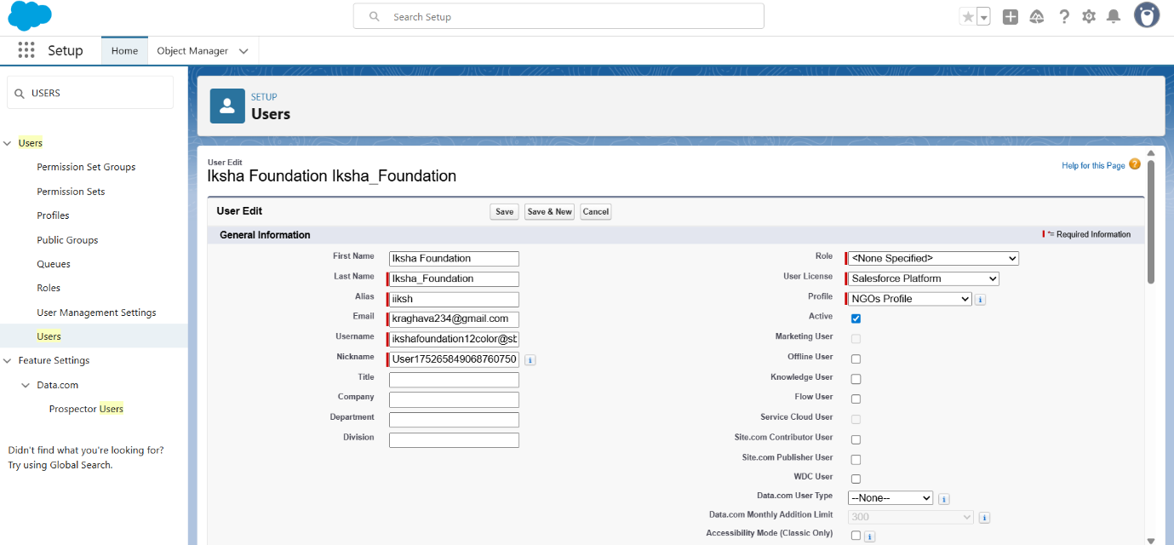

**Creation of User2, User3**

1. Create another Two Users by following steps in Activity - 1 with similar User License and Profile.

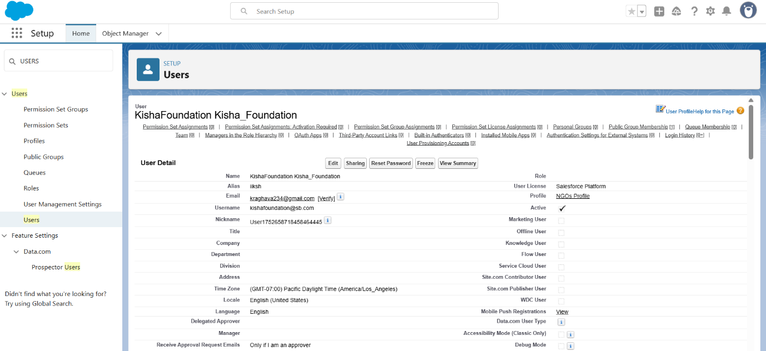

2. Give Different First Name, Last Name based on Different NGO’s.

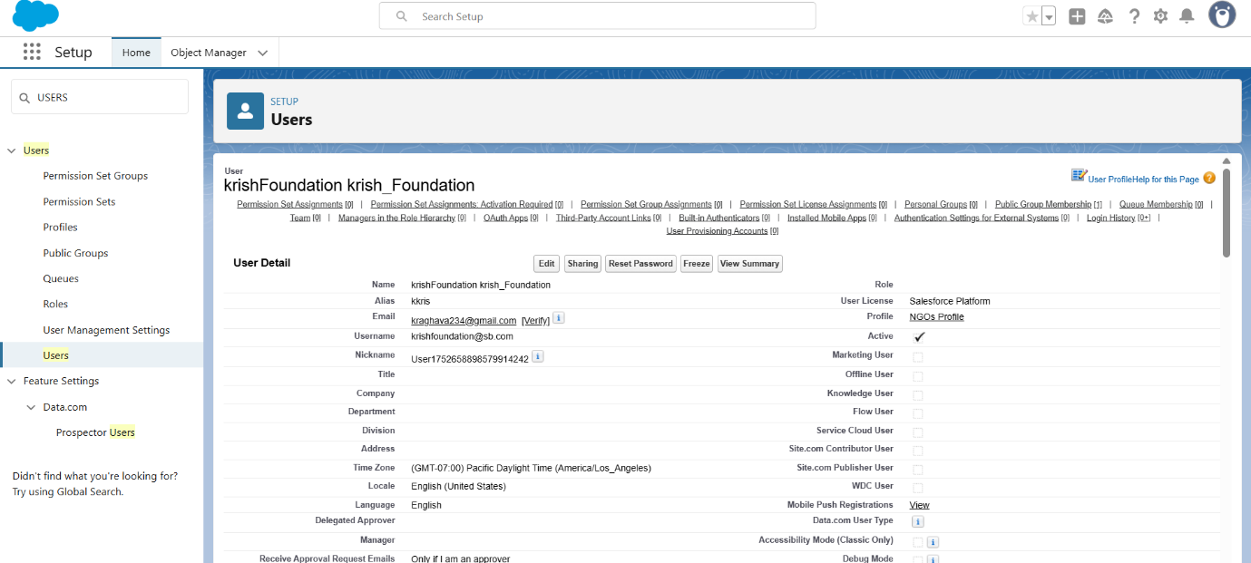

**Creation of sharing rules**

1. Go to setup >> type Sharing Settings in quick find box >>  Click on the Sharing Settings.
2. Scroll down and find Drop-Off point Sharing Rules.
3. Click on new near Drop-Off point Sharing Rules and Name it as:

Label: Rule 1

Rule Name: Rule_1

1. Select your rule type: Select Based on criteria.
2. Select which records to be shared:

Field: Operator: Value = Distance: less than: 15

1. Select the users to share with: Near Share With

Public Groups: Iksha

1. Click on Save.
2. Click on new near Drop-Off point Sharing Rules and Name it as:

Label: Rule 2

Rule Name: Rule_2

1. Select your rule type: Select Based on criteria.
2. Select which records to be shared:

Field: Operator: Value = Distance: greater than: 15

Field: Operator: Value = Distance: less or equal: 30

1. Select the users to share with: Near Share With

Public Groups: Kisha Foundation

1. Click on Save.
2. Click on new near Drop-Off point Sharing Rules and Name it as:

Label: Rule 3

Rule Name: Rule_3

1. Select your rule type: Select Based on criteria.
2. Select which records to be shared:

Field: Operator: Value = Distance: greater than: 30

Field: Operator: Value = Distance: less or equal: 50

1. Select the users to share with: Near Share With

Public Groups: Krish Foundation

1. Click on Save.

**Phase 5: Deployment, Documentation & Maintenance**

**Deployment Strategy:**

The deployment of the FOODCONNECT CRM from the sandbox environment to production was carried out using **Change Sets**, which facilitated secure and organized migration of metadata components including custom objects, fields, validation rules, flows, and Apex code. This method ensured that all dependencies were properly packaged and tested before final deployment, minimizing the risk of disruptions in the live environment.

**System Maintenance and Monitoring:**

The CRM is designed for ease of ongoing maintenance. Scheduled reports and dashboards help monitor daily operations, highlighting metrics like pending pickups and distributions completed. Regular data quality reviews are performed to identify duplicates or

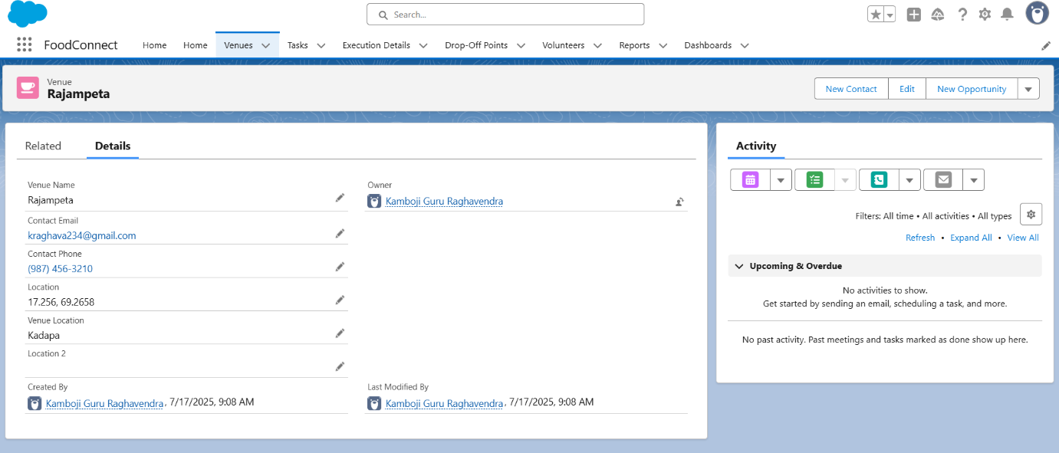

inconsistencies. Admins are responsible for periodic reviews of automation processes and ensuring that validation rules and flows continue to align with evolving business

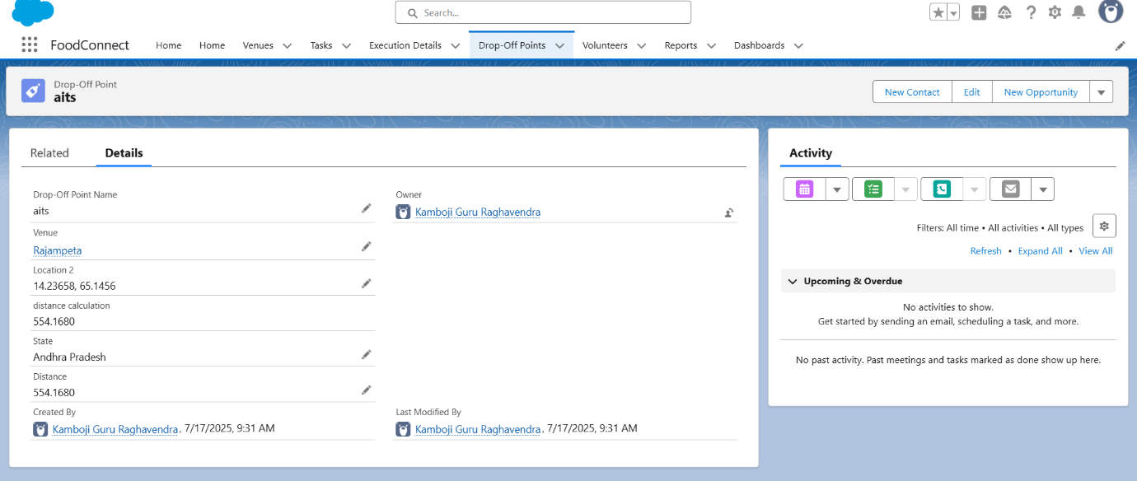

requirements. Any required enhancements or new features will be safely developed and tested in sandbox environments before being pushed to production.

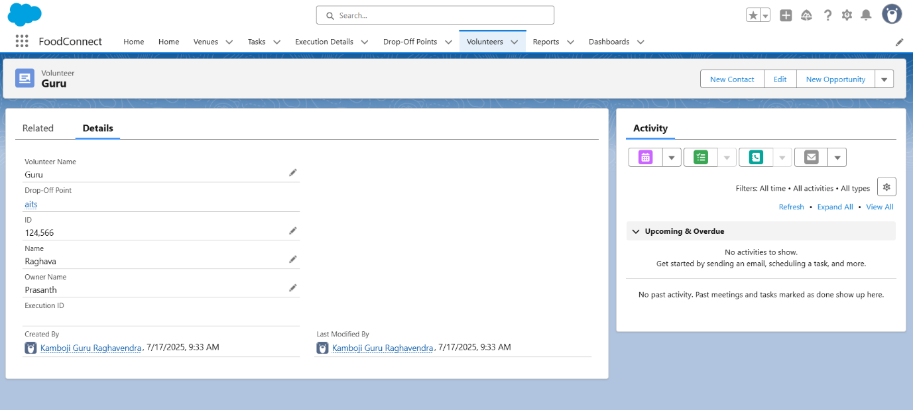

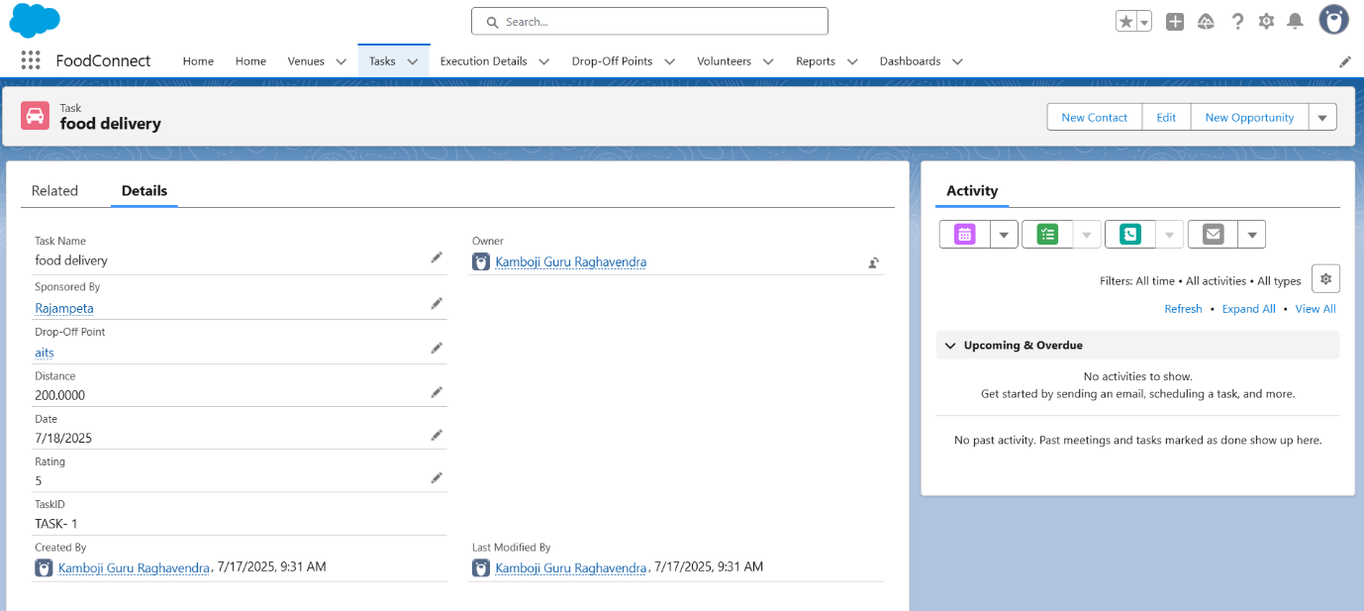

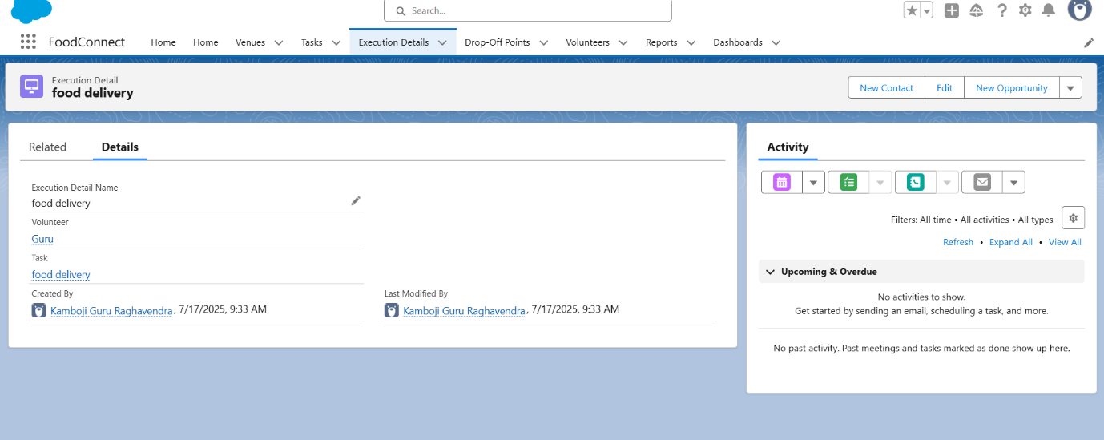

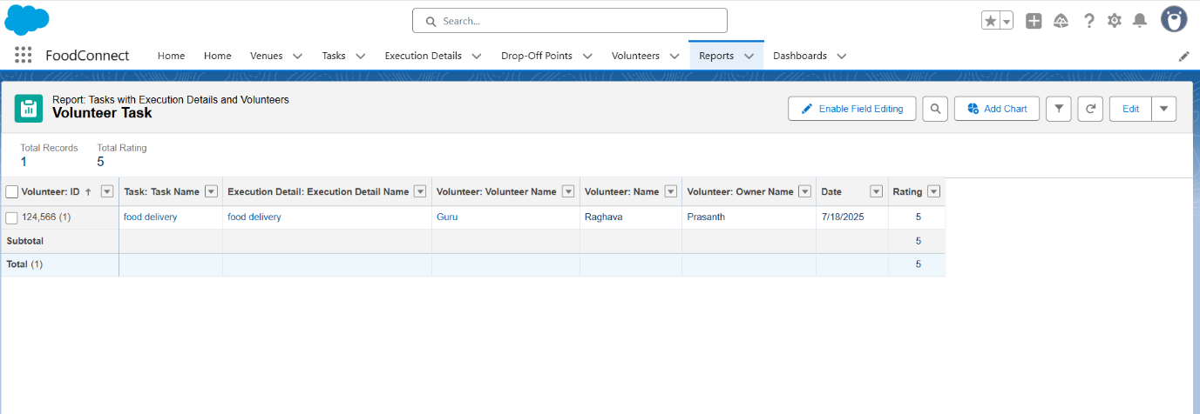

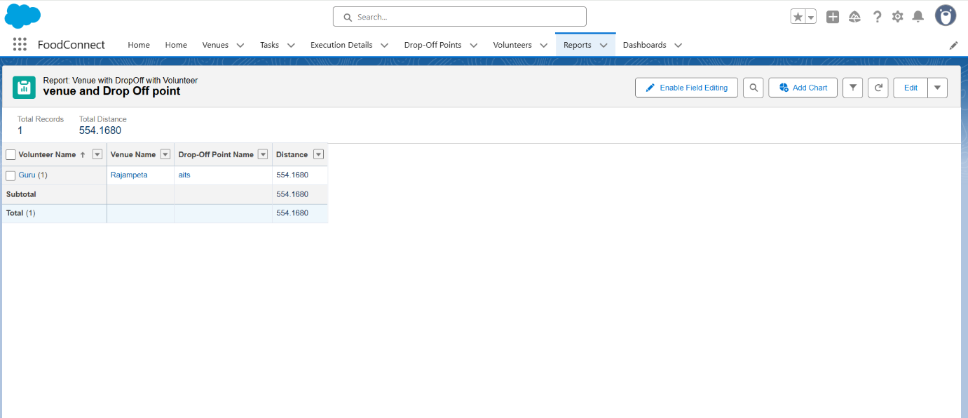

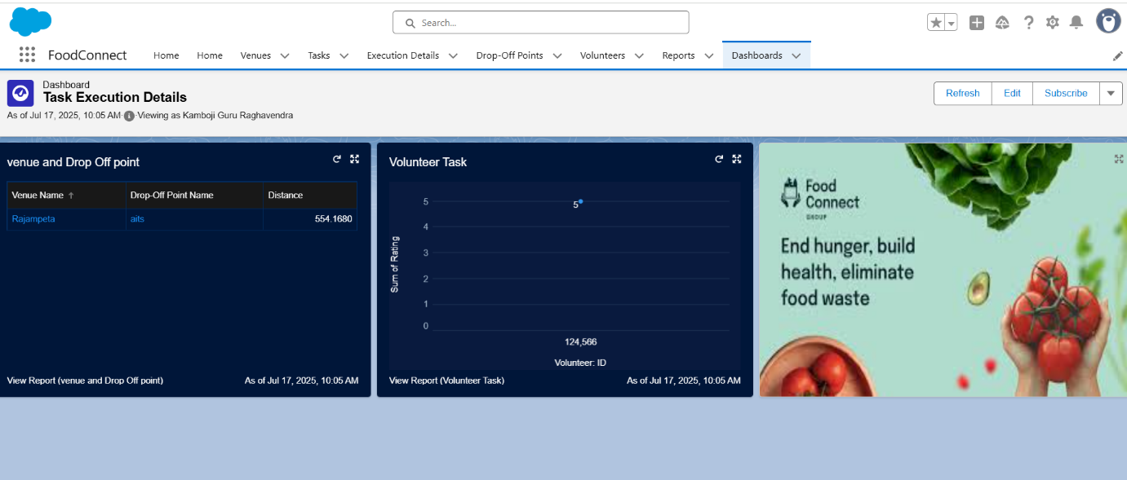

**Troubleshooting Approach:**

A systematic troubleshooting guide is maintained to resolve common issues such as failed pickups, notification errors, or data mismatches. Debug logs are reviewed to trace problems in Apex triggers or automation flows. Additionally, the CRM documentation includes details of object relationships, business logic, and error messages to assist technical teams in quickly diagnosing and fixing problems. This structured approach ensures system stability and minimizes downtime, supporting the mission of timely delivery of leftover food to the needy.

**Conclusion:**

The FOODCONNECT project successfully leverages Salesforce CRM to build a robust platform that bridges the gap between surplus food sources and underprivileged communities. By automating the process of collecting, scheduling, and distributing leftover food, the system minimizes manual coordination and reduces food wastage while ensuring timely delivery to the needy. The project enhances transparency, data tracking, and donor engagement through dashboards and automated communications. In addition, it establishes a scalable framework that can be easily extended to onboard more donors, NGOs, and volunteers in the future. Looking ahead, the system offers opportunities for further enhancement, such as integrating AI-based demand forecasting and chatbot-driven donor support, ultimately strengthening the mission to fight hunger and support the underprivileged.